**Math 163  
PS2: A somewhat Historical Approach to Power Series, Lesson 2  
Questions for flipped class**

**(PS2.1)**

Write  in sigma notation and then find the sum.

**(PS2.2)**

Write  in sigma notation with your index value beginning at zero. Then find the sum. When does this series converge?

**(PS2.3)**

Find a power series expansion for . When does it converge?

**(PS2.4)**

Find a power series expansion for . When does the series converge?

**(PS2.5)** Retirement question

Suppose you are 20 years old today and hope to retire at 65. What will be the future value of your retirement account if you save $100 at the end of every month for 45 years at 8% annual interest, compounded monthly?

To find this, think about it like 12*45=540 little investments whose sum is a geometric series.

**(PS2.6)** Retirement question

Suppose you retire at 65 with $500,000 in the bank earning 8% annual interest, compounded monthly. You expect to live to 85. How much money could you withdraw at the end each month?

To find this, think about how much you would need to have invested to make a withdrawal of *R* at the end of the first month. How much would you need to make a withdrawal of *R* after two months …. How much for the 240th withdrawal?

The sum of all these investments is $500,000. Set up an equation and solve for *R*.

**(PS2.1 solution)**

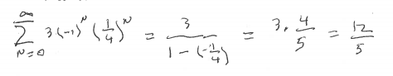

**(PS2.2 solution)**

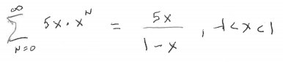

**(PS2.3 solution)**

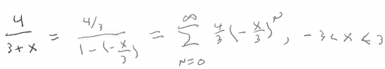

**(PS2.4 solution)**

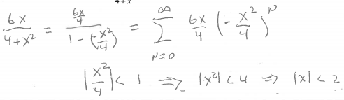

**(PS2.5 solution)**

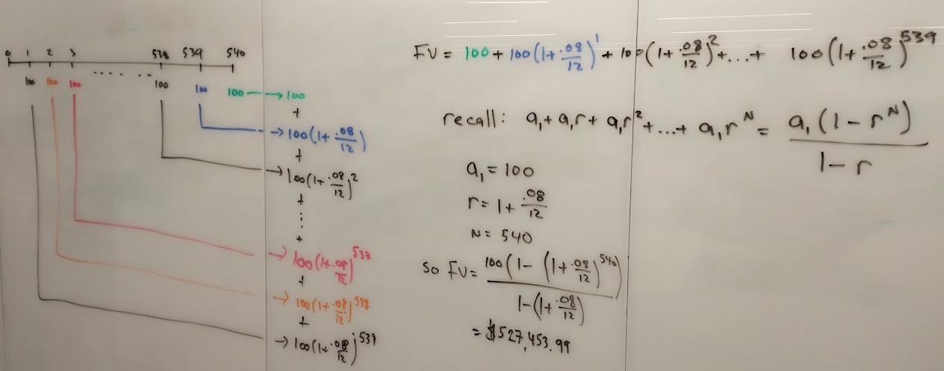

**(PS2.6 solution)**

