**Math 163  
15.2B: Double Integrals over General Regions  
Questions for flipped class**

**(15.2.1)**

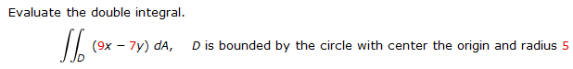

**(15.2.2)**



**(15.2.3)**



**(15.2.4)**



**(15.2.5)**

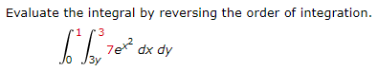

**(15.2.6)**

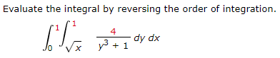

**(15.2.1 solution)**

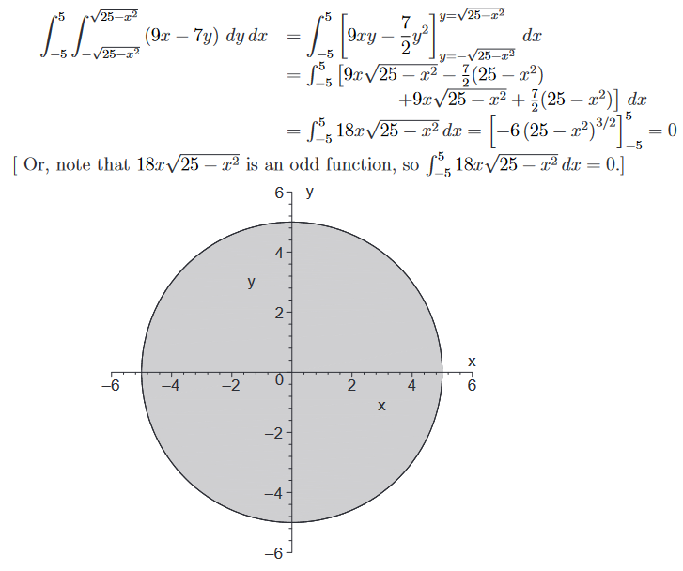

**(15.2.2 solution)**

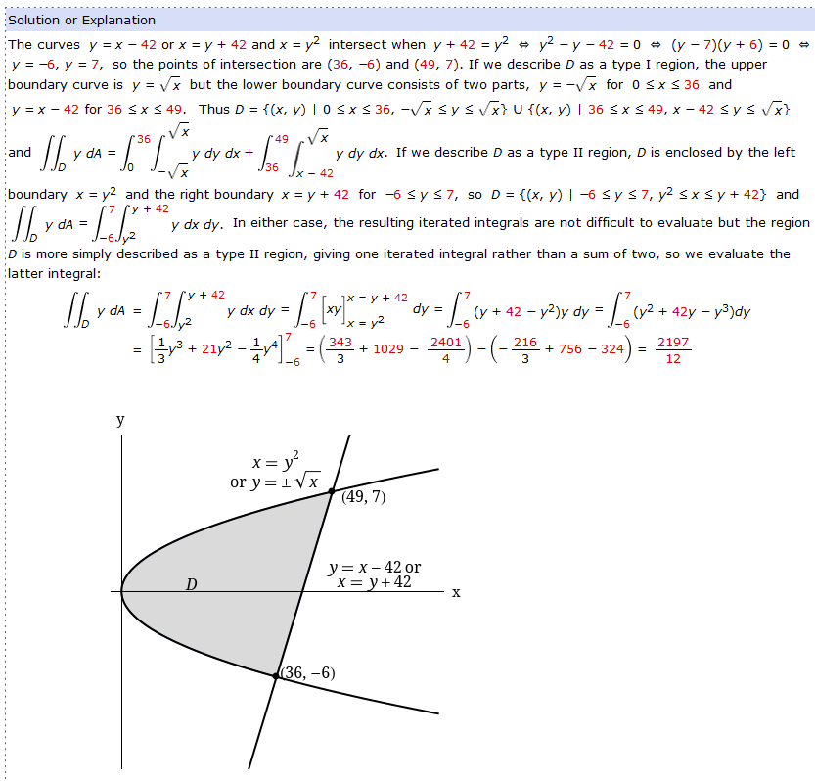

**(15.2.3 solution)**

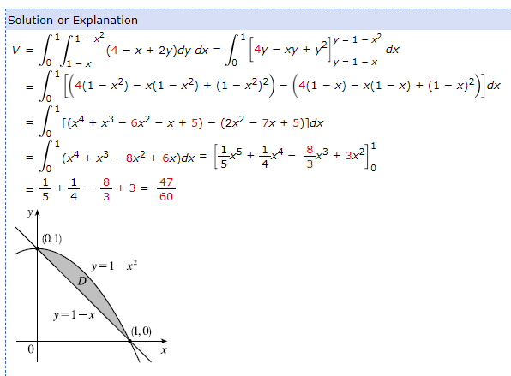

**(15.2.4 solution)**

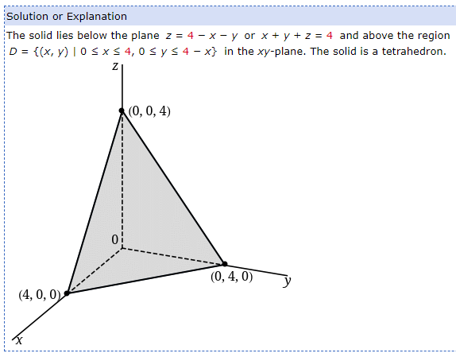

**(15.2.5 solution)**

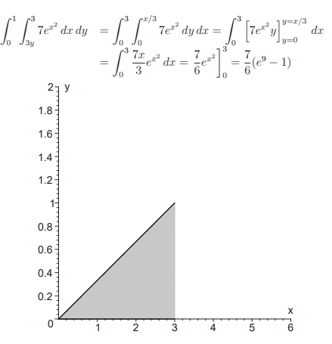

**(15.2.6 solution)**

