**Math 163  
14.6: Directional Derivatives and the Gradient Vector  
Questions for flipped class**

**(14.6.1)**

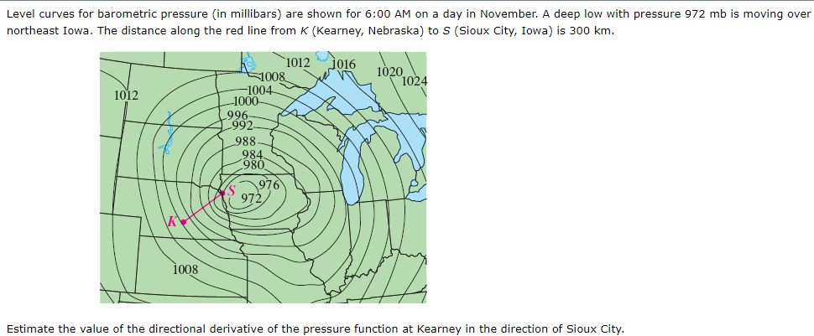

**(14.6.2)**

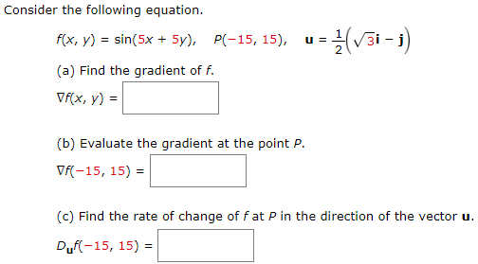

**(14.6.3)**



**(14.6.4)**



**(14.6.5)**

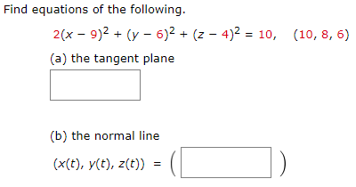

**(14.6.6)**

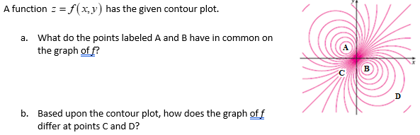

**(14.6.7)**

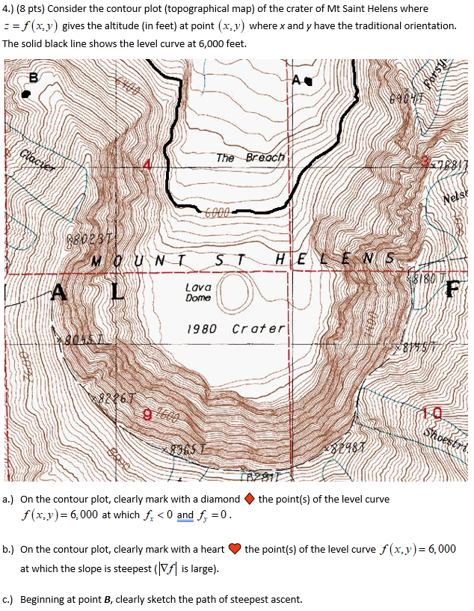

**(14.6.1 solution)**

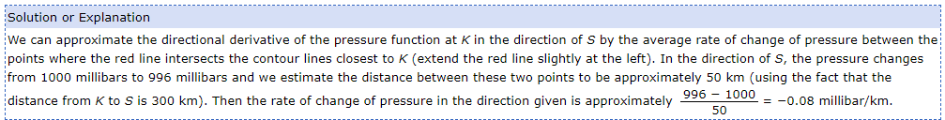

**(14.6.2 solution)**

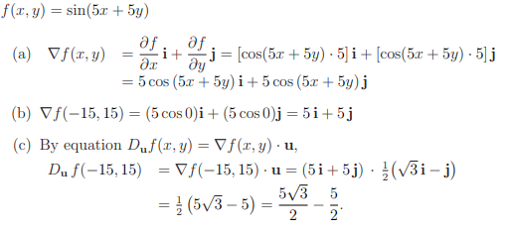

**(14.6.3 solution)**

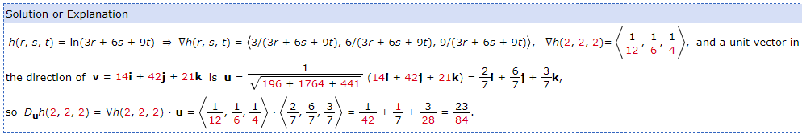

**(14.6.4 solution)**

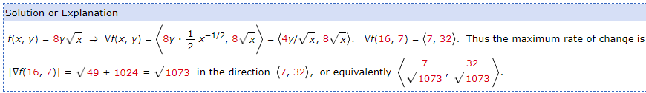

**(14.6.5 solution)**

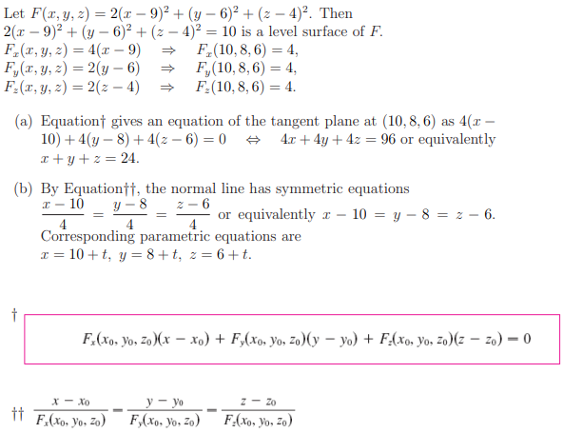

**(14.6.6 solution)**

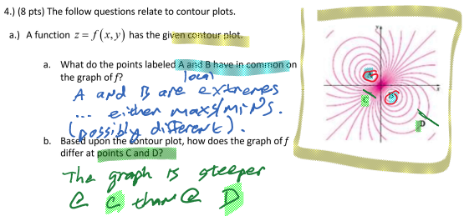

**(14.6.7 solution)**

