**Math 163  
14.1: Functions of Several Variables  
Questions for flipped class**

**(14.1.1)**



**(14.1.2)**



**(14.1.3)**



**(14.1.4)**



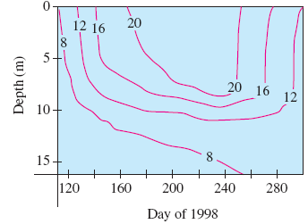

**(14.1.5)**



**(14.1.6)**



**(14.1.1 solution)**

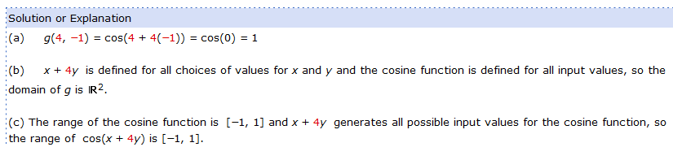

**(14.1.2 solution)**

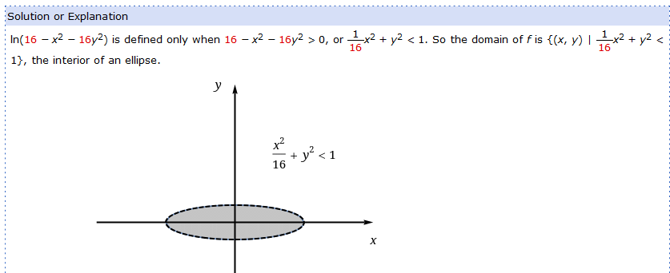

**(14.1.3 solution)**

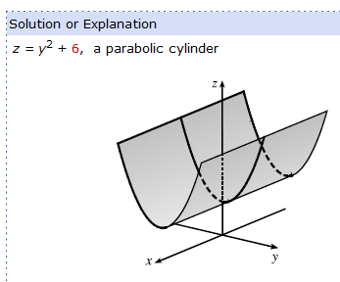

**(14.1.4 solution)**

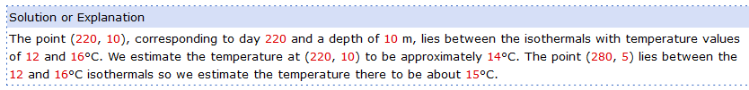

**(14.1.5 solution)**

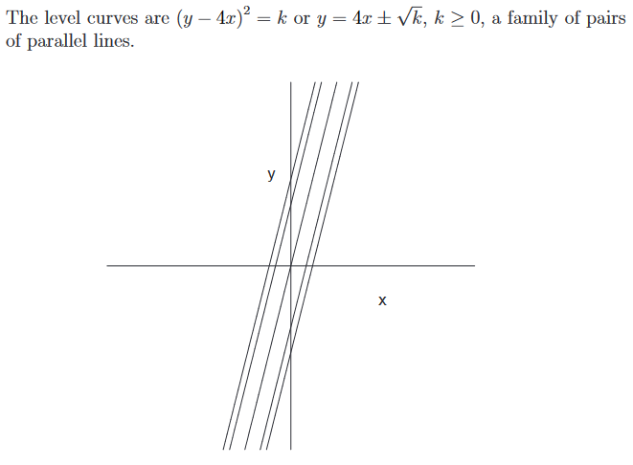**(14.1.6 solution)**

