**Math 163  
13.3: Calculus with Parametric Equations  
Questions for flipped class**

**(13.3.1)**



**(13.3.2)**

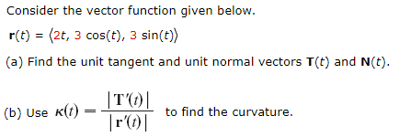

**(13.3.3)**



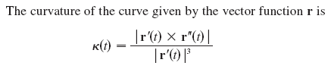

**(13.3.4)**

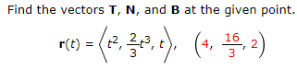

**(13.3.1 solution)**

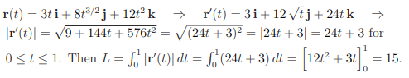

**(13.3.2 solution)**

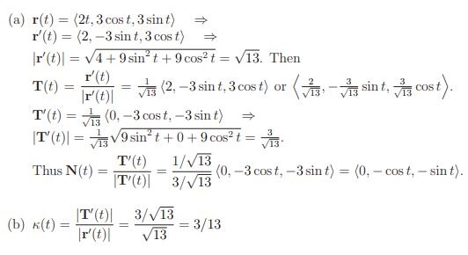

**(13.3.3 solution)**

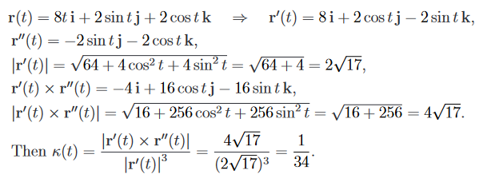

**(13.3.4 solution)**

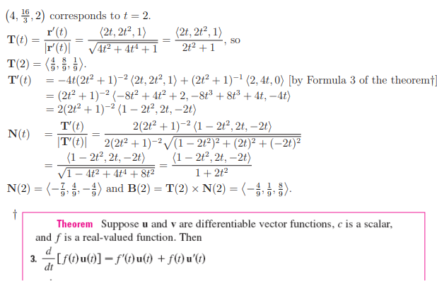

**(13.3.5 solution)**

**(13.3.6 solution)**