**Math 163  
12.2 Questions for flipped class**

**(12.2.1)**

(a.)



(b.)



**(12.2.2)**



**(12.2.3)**

(a.)



(b.)



**(12.2.4)**



**(12.2.5)**

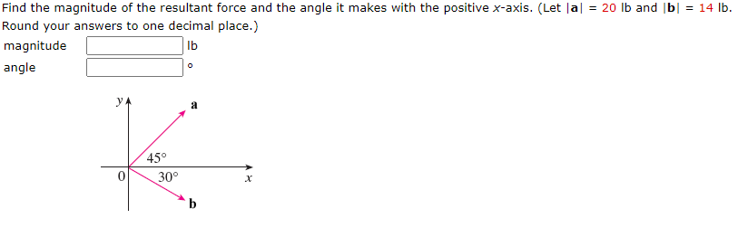

**(12.2.6)**

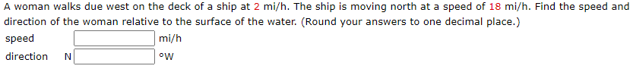

**(12.2.1 solution)**

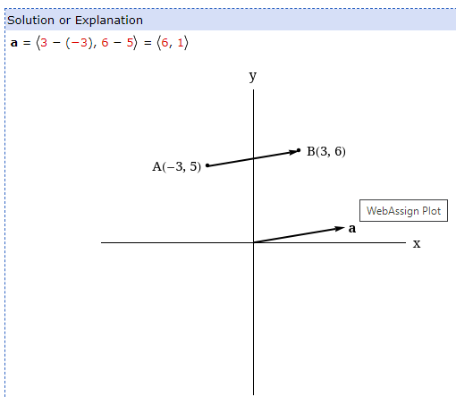

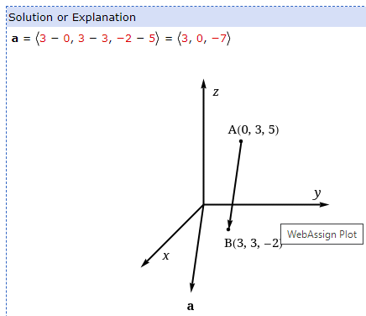

**(12.2.2 solution)**

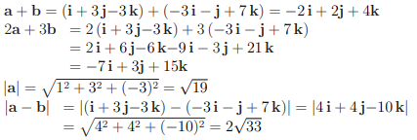

**(12.2.3 solution)**

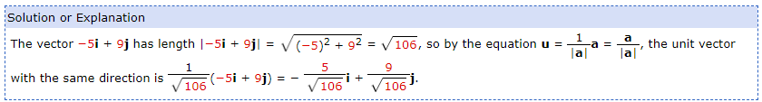

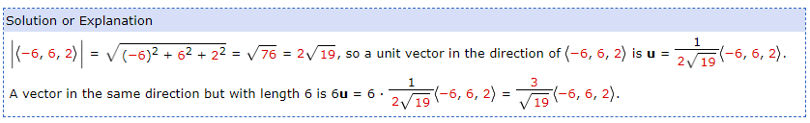

**(12.2.4 solution)**

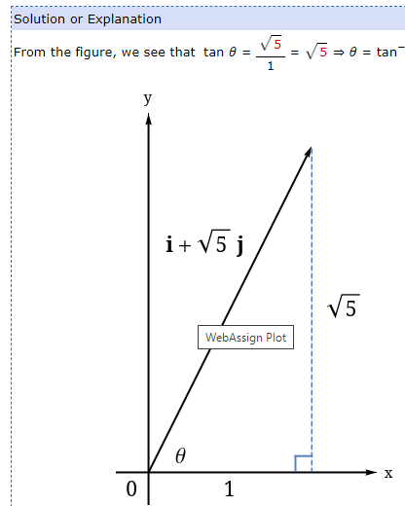

**(12.2.5 solution)**

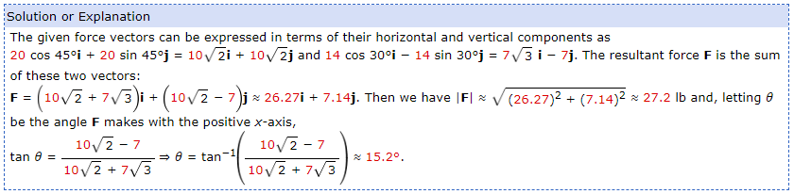

**(12.2.6 solution)**

