**Math 163  
10.2: Calculus with Parametric Equations  
Questions for flipped class**

**(10.2.1)**

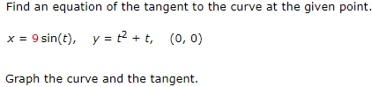

**(10.2.2)**



**(10.2.3)**

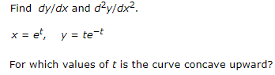

**(10.2.4)**



**(10.2.5)**



**(10.2.6)**



**(10.2.1 solution)**

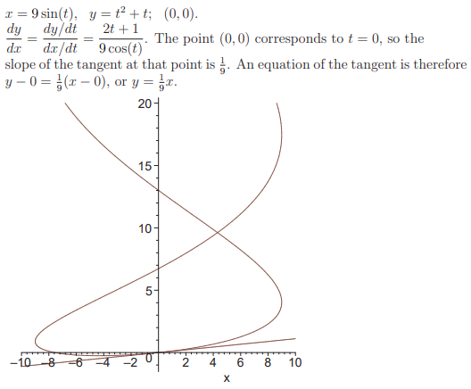

**(10.2.2 solution)**

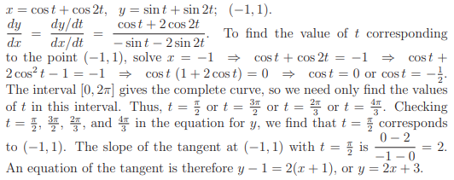

**(10.2.3 solution)**

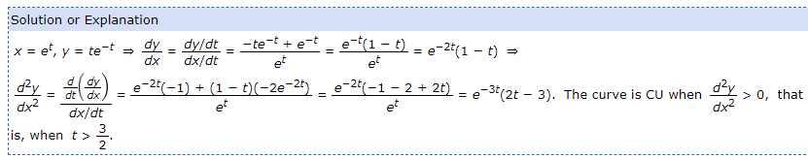

**(10.2.4 solution)**

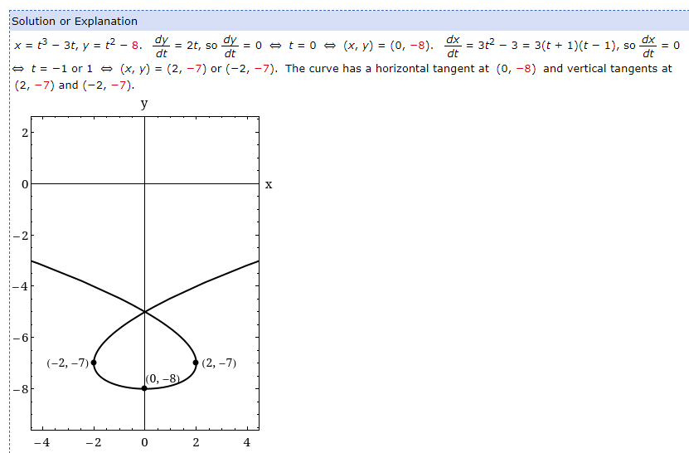

**(10.2.5 solution)**

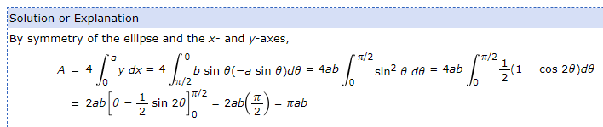

**(10.2.6 solution)**

