|  |  |
| --- | --- |
| Assessment 6Dusty Wilson Math 163 No work = no credit | **Name**: _____________________________  *With the exception of the geometric series, there does not exist in all of mathematics a single infinite series whose sum has been determined rigorously.* Niels Henrik Abel 1802-1829 (Norse mathematician) |

|  |  |  |  |
| --- | --- | --- | --- |
| Warm-ups (1 pt each): | = | = | = |

(1 pt) We are just beginning to learn about power series (infinite series). The example yesterday about investing related to the geometric series. Based upon the quote above, do you think Abel was satisfied with the way he had learned about infinite series? Answer using complete English sentences.

(5 pts) If  and  changes from  to  compare the values of  and .

(20 pts) Answer the following partial derivative questions.

1. Consider 
   1. Find 
   2. Find 
2. Find the directional derivative of  at the point  in the direction of the vector .
3. If , , and , find .

(10 pts) Consider the contour plot (topographical map) of the glaciers near Paradise on Mt Rainier where  gives the altitude (in feet) at point  where *x* and *y* have the traditional orientation. The solid black line shows the level curve at 8,600 feet.

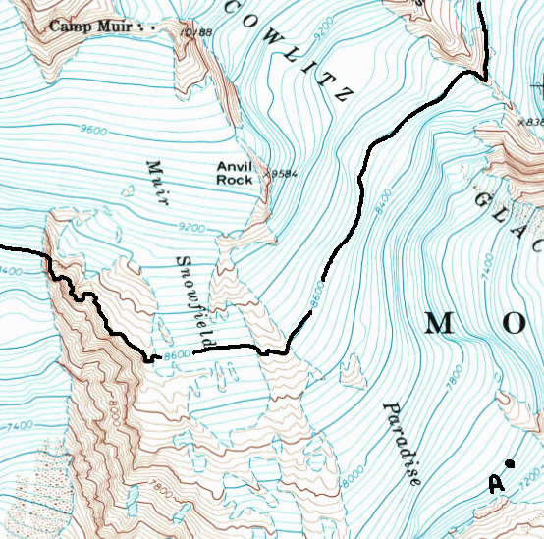

1. What would happen if a hiker walked along the level curve .
2. On the contour plot, clearly sketch at least 5 possible gradient vectors along the level curve .
3. On the contour plot, clearly mark with a diamond ♦ the point(s) of the level curve  at which  and .
4. On the contour plot, clearly mark with a heart ♥ the point(s) of the level curve  at which the slope is greatest ( is large).
5. Beginning at point ***A***, clearly sketch the path of steepest ascent.