***Derivatives and Integrals of Vector Functions***

* **Derivatives**

The **derivative ** of a vector valued function  is defined in much the same as it was for real-valued functions:  if this limit exists.

|  |  |
| --- | --- |
| The geometric significance of this definition is shown in the diagrams to the right. If the points *P* and *Q* have position vectors  and , then  represents the vector which can therefore be regarded as a secant vector. |  |
| If , the scalar multiple  has the same direction and as , it appears that this vector approaches a vector that lies on the tangent line. For this reason, the vector  is called the **tangent vector** to the curve (provided it exists and is non-zero). This is shown to the right. |  |

We will also have occasion to consider the **unit tangent vector** which is 

The following theorem gives us a convenient method for computing the derivative of a vector function ; just differentiate each component of .

**Theorem**: If  where *f*, *g*, and *h* are differentiable functions, then 

**Example 1**: Find the velocity, speed and acceleration of a particle whose motion in space is given by the position vector .

**Example 2**: Find the unit tangent vector of the curve 

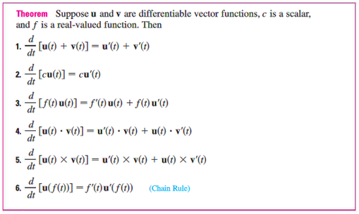

* **Integrals**

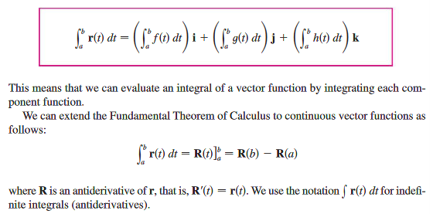

This means we can evaluate an integral of a vector function by integrating each component function. We can also extend the Fundamental Theorem of Calculus to continuous vector functions as follows:



**Example 3**: Suppose . Evaluate the following integrals:

1. 
2. 

**Example 4**: Suppose we don’t know the path of a hang glider, but only its acceleration vector . We also know that at take-off (where) the glider departed from the point  with velocity . Find the glider’s position as a function of .