***Cylinders and Quadric Surfaces***

We have already looked at two special types of surfaces: planes and spheres. Here we investigate two other types of surfaces: cylinders and quadric surfaces.

In order to sketch the graph of a surface, it is useful to determine the curves of intersection of the surface with the planes parallel to the coordinate planes. These curves are called **traces** (or cross-sections) of the surface.

A **cylinder** is a surface that consists of all lines that are parallel to a given line and that pass through a given plane curve.

The following are examples of cylinders:

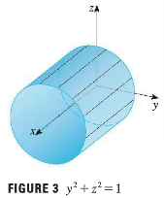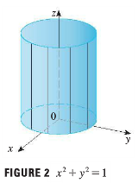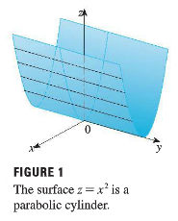

Notice that in each equation a variable is missing. This is typical of a surface whose rulings are parallel to one of the coordinate axes. If one of the variables is missing from the equation of a surface, then the surface is a cylinder.

NOTE: When you are dealing with surfaces, it is important to recognize that an equation like represents a cylinder and not a circle. The trace of the cylinder  in the *xy*-plane is the circle with the equations .

**Example 1**: Graph 

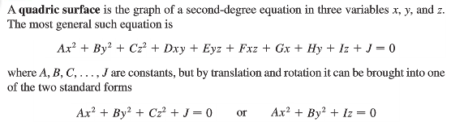

Quadric surfaces are the counterparts in three dimensions of the conic sections in the plane (parabola, ellipse, and hyperbola).

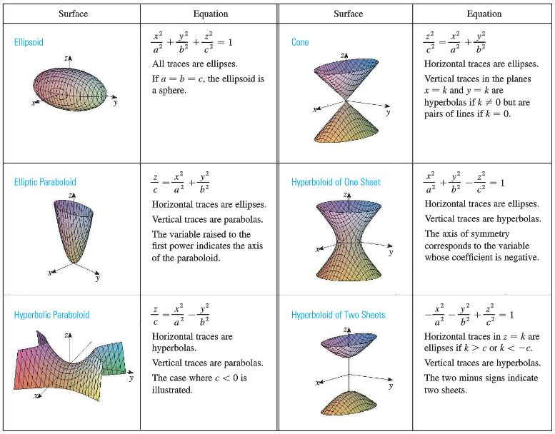

<http://demonstrations.wolfram.com/PlaneSectionsOfSurfaces/>

NOTE: For Hyperboloid you can think of . If we have  then we have hyperboloid of one sheet. Otherwise it is a hyperboloid of two sheets. Since the coefficient of *z* is negative the hyperboloids open toward *z*-axis.

**Example 2**: Identify each quadric surface and graph the cone, and elliptic paraboloid if any!

|  |  |
| --- | --- |
|  |  |
|  | **Math is crazy**: Two spheres can be formed from one! Yup, that’s right.   The Banach–Tarski paradox states: Given a solid ball in three-dimensional space, there exists a decomposition of the ball into a finite number of disjoint subsets, which can then be put back together in a different way to yield two identical copies of the original ball. Indeed, the reassembly process involves only moving the pieces around and rotating them without changing their shape |