|  |  |  |  |  |  |
| --- | --- | --- | --- | --- | --- |
| Assessment 8Dusty Wilson Math 163 No work = no credit **No CAS Calculators** | | **Name**: ________________________________  *All truths are easy to understand once they are  discovered; the point is to discover them.* Galileo Galilei 1564 - 1642 (Italian mathematician) | | | |
| Warm-ups (1 pt each): | =_____ | | =_____ | = |

(1 pt) Please paraphrase the quote by Galileo (above). Answer using complete English sentences.

(8 pts) If , , and , find .

(8 pts) Consider the function  at .

1. Find the linearization and use it to approximate .

1. Find the directional derivative in the direction of the vector 

1. If  changes from  to , compare the exact change and approximate change 

(8 pts) Consider the contour plot (topographical map) of the crater of Mt Saint Helens where  gives the altitude (in feet) at point  where *x* and *y* have the traditional orientation. The solid black line shows the level curve at 6,000 feet.

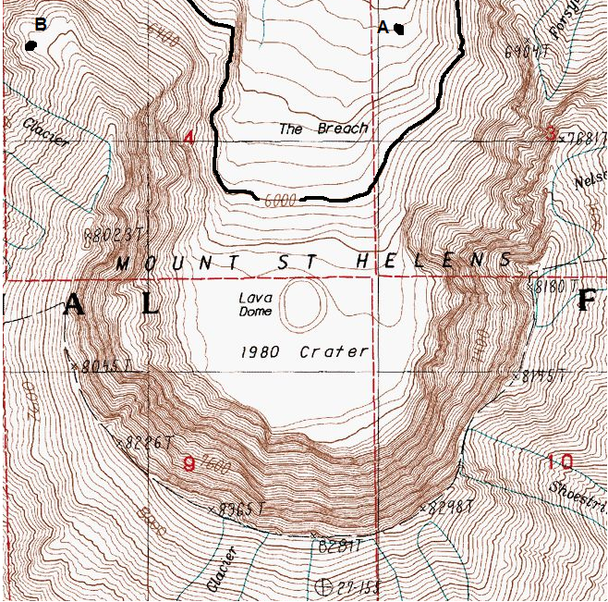

1. On the contour plot, clearly mark with a diamond ♦ the point(s) of the level curve  at which  and .
2. On the contour plot, clearly mark with a heart ♥ the point(s) of the level curve  at which the slope is steepest ( is large).
3. Beginning at point ***B***, clearly sketch the path of steepest ascent.

(0 pts). Would you like this Assessment to count double? **Clearly** circle one: YES NO.