We will now look at the case where has no solution. What would be “closest” possible solution ? This is called the Least-Squares problem, and it mirrors our Best-Approximation Theorem from 6.3.

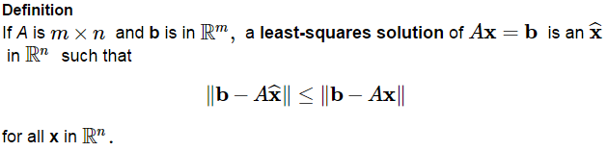

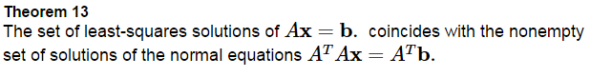

Find a least-squares solution of the inconsistent system  for

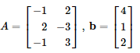

Find a least-squares solution of the inconsistent system  for

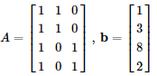

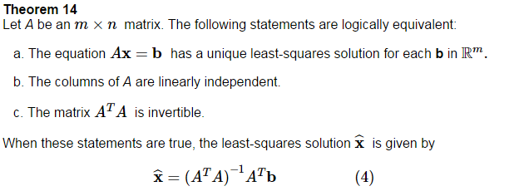

The distance from **b** to *A***x** is called the _______________________ _____________

Find the least-squares error of Ex 1.

If the columns of A are orthogonal, the least-squares solution is even easier to find.

Verify the columns of A are orthogonal and find a least-squares solution of.

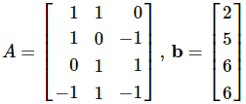

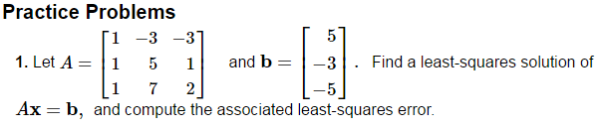

Now we’re going to look at finding a best-fit line for a set of data points, also known as linear-regression.

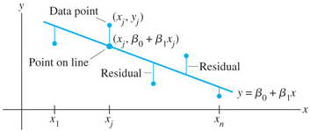 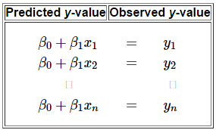

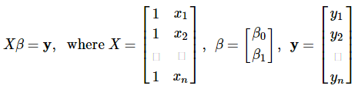

Find the equation  of the least-squares line that best fits the data points. 

Find the quadratic regression equation  of the least-squares line that best fits the data points. .

