Big Picture: We are building to a method (Gram-Schmidt Orthogonalization) that will allow us to use an existing basis to create an orthonormal basis. These concepts will then help us to develop a method for calculating least square models.

Given a vector  and a subspace  in  there is a vector  such that

1)  is the unique vector in *W* for which  is orthogonal to *W*

2)  is the unique vector in *W* closest to 

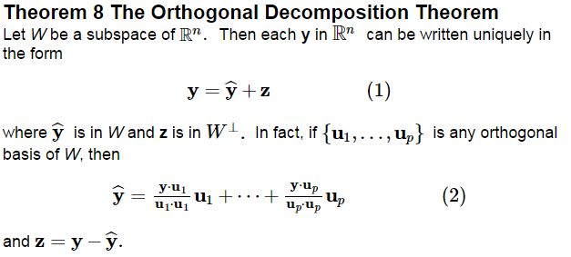

Let . Write as the sum of a vector in  and a vector orthogonal to .

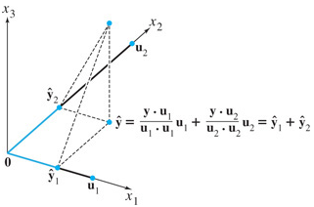

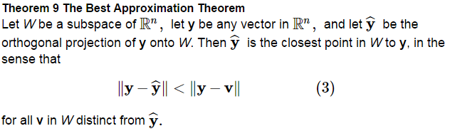

As in Ex 1,  is the closest point in  to . Find the distance from  to 

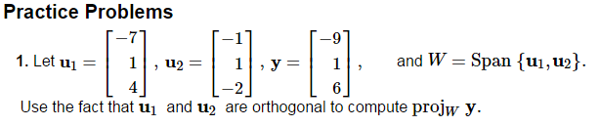

**2.** Let W be the subspace spanned by the **u**'s, and write **y** as the sum of a vector in W and a vector orthogonal to W.

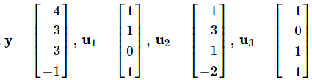

**The Gram-Schmidt Process**

Let , construct an orthogonal basis .

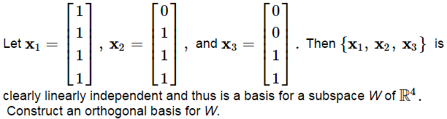

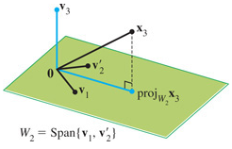

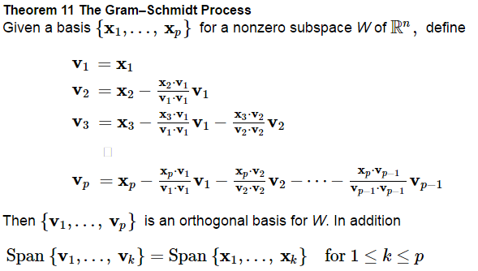

The result of this is that every nonzero subspace  in  has an orthogonal basis.

An orthonormal basis is constructed easily by normalizing all the ’s to unit vectors.

Re-write the orthogonal basis found in Ex 3 as an orthonormal basis.

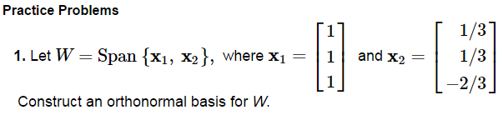

**2.** Use the Gram–Schmidt process to produce an orthogonal basis for W.

 where 