If **u** and **v** are vectors in  then we can think of them as  matrices.

So is a ___________ matrix and the product of  is a _____________ matrix.

We will write this as a real number without brackets, and call  the ___________ ___________________ of **u** and **v.**  It is also written as and called the ________ ___________________.

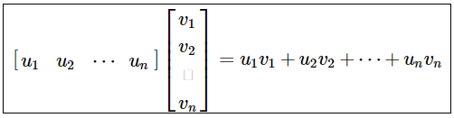

Compute  and  for  and 

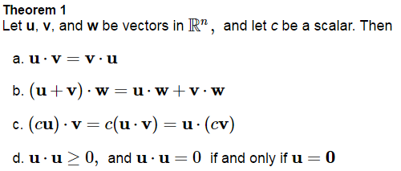



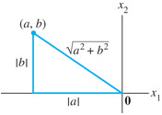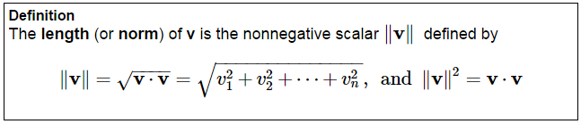

In  this is essentially the

___________________________ theorem.



A vector whose length is one is called the _____________ vector.

If we divide a non-zero vector **v** by it’s length, ______________________________ we get a unit vector in the same direction as **v**. This is called _______________________.

Let . Find a unit vector **u** in the same direction as **v.**

Let *W* be a subspace of  spanned by . Find a unit vector basis for W.

How do we find the distance between two numbers on a number line?

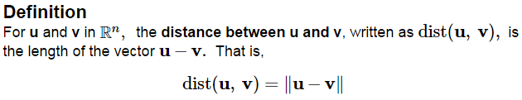



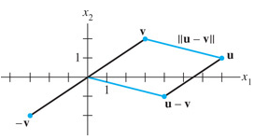

Find the formula for the distance between two vectors****





If a vector **z** is orthogonal to every vector in a subspace W of , then **z** is said to be _______________________________________. The set of all of these orthogonal vectors to W is called the __________________________ ___________________of W and is denoted by .

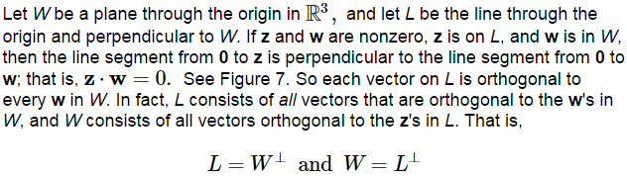

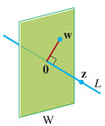

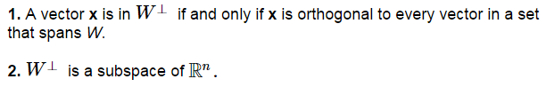

Remember our comment in 4.6 that the Null Space and Row Space are essentially orthogonal to each other.

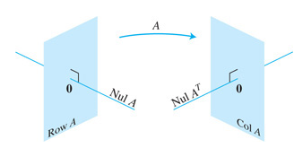

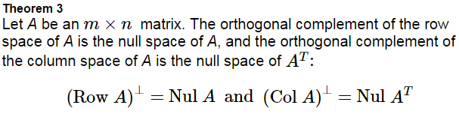

Using the Null Space and Row Space of **Ex 5 from 4.6**, check that random vectors from each are orthogonal to each other.



Show that where  is the angle between the two vectors, using the Law of Cosines,



