**Linear Equations**

A ________________ _________________ of the variables  has the form



Where  are real or complex numbers.

Circle the linear equations, and state why the non-linear aren’t linear.



A _____________________ ____ ___________________ ________________ is a collection of one or more linear equations with the same variables. For example



A _______________________ of a system is a list of numbers  that make every equation of the system true, when each  is substituted for .

Verify that (3,2,1) is a solution to the system .

The set of all possible solutions is called the ____________________ _________.

Find another solution to the system from Ex 2.

Two systems are considered _________________________ if they have the same solution set.

From 2 dimensional systems of equations in algebra, we should remember that there are 3 possibilities for the number of solutions to a system.

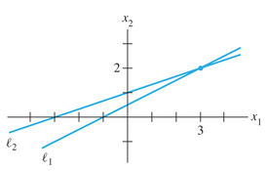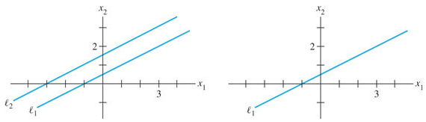

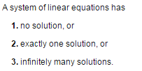

A system is called _________________________ if it has at least one solution, and ____________________________ if it has no solutions.

**Matrix Notation**

We will represent a system of equations by its coefficients in a __________________.

 will be re-written as the

____________________ matrix

The __________ of a matrix tells  
how many __________ and ______________  
a matrix has. _____________________ matrix

An  matrix has   
____ ______________ and  
____ ________________________.

**Solving a Linear System** – We are going to describe an algorithm for solving linear systems, which replaces one system with an equivalent one that is easier to solve. Since they are equivalent, they have the same solution set.

Solve the system Three Operations we can use:



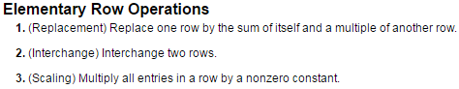

Two matrices are called ___________ ______________________ if there are a sequence of elementary row operations that transform one matrix into the other.

If two systems are row equivalent, they have the same __________________ _____.

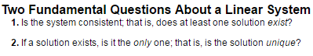

Determine whether the systems are consistent or inconsistent. Do not fully solve.



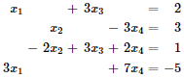Determine whether the systems are consistent or inconsistent. Do not fully solve.