**Double Integrals in Polar Coordinates**

Objective:

1. Double Integrals in Polar Coordinates
2. ***Double Integrals in Polar Coordinates***

In this section we will study double integrals in which the integrand and the region of integration are expressed in polar coordinates. Such integrals are important for two reasons: First, they arise naturally in many applications, and second, many double integrals in rectangular coordinates are more easily evaluated if they are converted to polar coordinates.

Important formulas we will need:

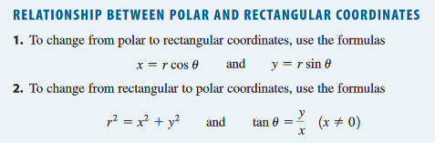

Ex1: Evaluate 

To find the volume of a solid bounded by the region  in the xy-plane and a surface , we follow the same method as previous sections. (1) Dividing  into  small polar “rectangles” (circular arcs and rays) of area , (2) picking a sample point in each rectangle, (3) Find the volume of each cylinder by , (4) adding the volumes, (5) and finally allowing  to increase infinitely.

|  |  |  |
| --- | --- | --- |
|  |  |  |
| (1) | (2) | (3) |

So the volume of the solid can be expressed as: . But how do we calculate (the area of the polar “rectangles”)?

We will calculate *dA* intuitively by considering the small polar “rectangle” pictures

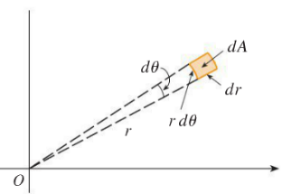

Thus the formula that we need to remember is: .

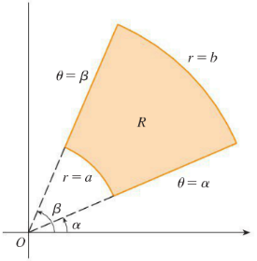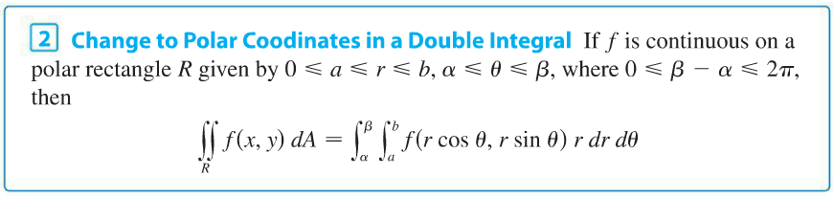

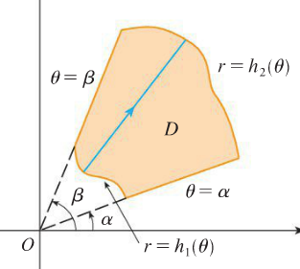

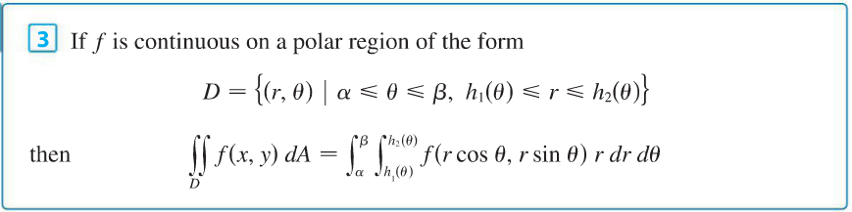

Now let’s go back to example 1 and use polar coordinates to evaluate it!



Ex2: Use a double polar integral to formulate the volume of a sphere of radius .

Ex3: Set-up an integral to represent  where *R* is the area outside the circle  and inside .

As we saw in calculus III, double integrals can be used to find area of a region *D*:

Area of 

Ex4: Use a double polar integral to find the area enclosed by the three-pedaled rose 

Historical anecdote: There is a famous story about the nineteenth-century Scottish physicist Lord Kelvin. “Do you know what a mathematician is?” Kelvin once asked a class. He stepped to the blackboard and wrote:



“A mathematician,” he continued, “is one to whom that is as obvious as 2*2 = 4 is to you.” Let’s explore just how obvious this really is …

Ex5: evaluate 

Reflection on the anecdote: After working through this example it is clear that this formula is *not* obvious to your teacher or anyone who he knows. The conclusion seems to be that Kelvin was both showing off and trying to put down his class in a rather mean-spirited way.

Application: This integrand is called the normal or Gaussian distribution and is important in probability theory. The general form is where  represents the mean and  the standard deviation of a distribution. Some examples of (roughly) normally distributed variables include height, rolling a dice, tossing a coin, IQ, technical stock market, income distribution, shoe size, birth weight, and student grades .