Intro: These sections focus on a number of characteristics of common subspaces: dimension, rank, nullity, and the row space.

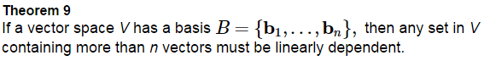

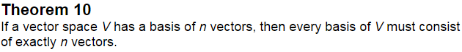

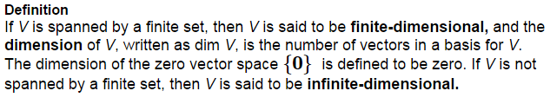

Find the following

1. _____
2. 
3. _____
4. (recall *P* = all polynomials)
5. Given  we can see
6. Given  we can see

Find the dimension of the subspace

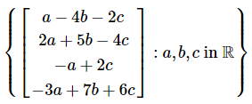

The subspaces of  can be classified by dimension now.

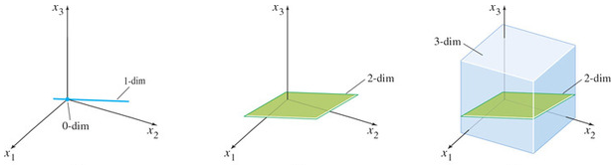

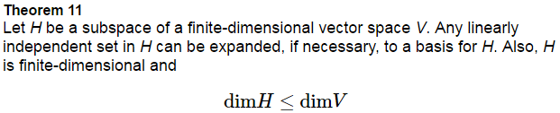

Proof:

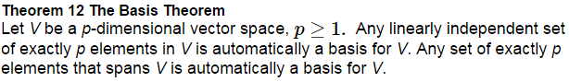

Proof:

What can we say about the dimension of Col A and Nul A?

The dimension of the null space of A is

The dimension of the column space of A is:

Determine the dimensions of the null space and the column space of A.



**Row Space**

The set of all the linear combinations of the row vectors of an  matrix *A* is called the _______ _______________ of *A*, and is denoted by ______________. Since there are *n* entries in each row, Row *A* is a subspace of . Also, Row *A* = _____________.

Find a spanning set for Row *A*.



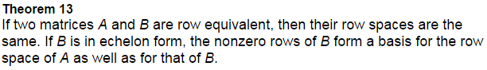

Find bases for the row space, column space, and null space of A.



The _____________ of A is the dimension of the column space of A.

The _____________ of ______ is the dimension of the row space of A.

The _____________ of A is the dimension of the null space of A (though this text just uses ________________.)

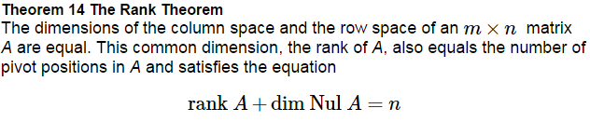

(See proof on page 235.)

a)If A is an _____x______ matrix with three-dimensional null space, what is the rank of A?

b) Could a 3x5 matrix have a one-dimensional null space?

In chapter 6 we will learn that Row A and Nul A have only the ____________ _________________ in common, and they are actually _______________________ to each other. ***Take a look at example 4 on page 236.***

