While the matrix equation _____________ and the vector equation _______________________________ are essentially the same except for notation, there is a case where the matrix equation represents an action on a vector that isn’t directly connected with a linear combination of vectors.

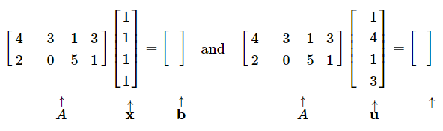

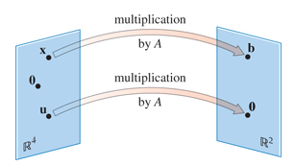

Does this picture look familiar from other math you’ve seen?

A ____________________________ *T* from  to is a rule that assigns each vector to a vector .

The set  is called the _________________ of *T*.

The set is called the _________________ of *T*.

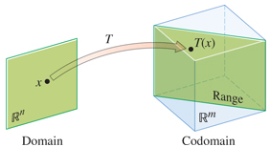For , the vector is called the _____________ of .

The set of all ________________ 

is called the ______________ of *T*.

Review Ex. 5 on page 68 of a Rotation Transformation.

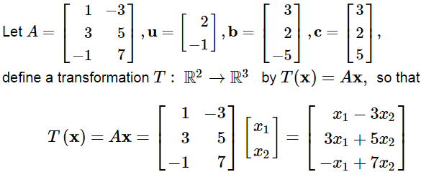

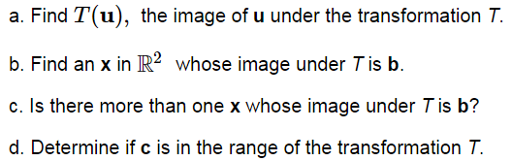

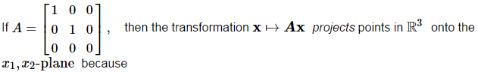

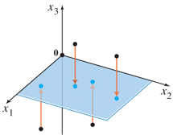



called a ______________ ___________________________.

For the image below, let’s look at the transformations of the vectors 

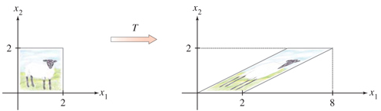

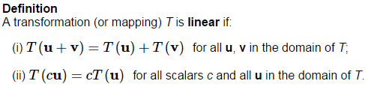

Since the above properties are true for all matrices, then every _________________ transformation is a ___________________ transformation. (Though the reverse is not true.)

Furthermore, (mini proof)

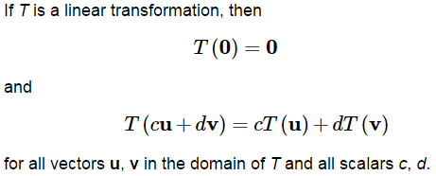

The second property here actually can be generalized to



This is referred to as a ______________________ ____________________ in engineering and physics.



________________________  __________________

 Let  and show that T is a linear transformation.



