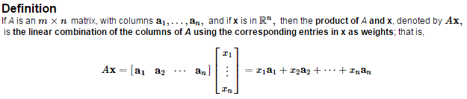

 is only defined if the number of ______________ of A equals the number of _____________ in **.**

Calculate the produce 





For  Write the linear combination of  as a matrix times a vector.



Write the system of equations as a

1. Vector Equation
2. Matrix Equation
3. Augmented matrix

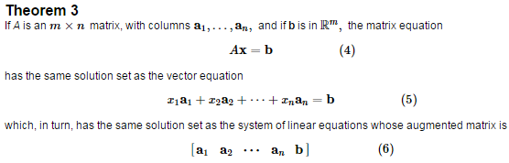

The equation  has a solutions if and only if **b** is a ________________ ______________________ of the columns of *A*.

Let  and . Is the equation  consistent for all possible ?

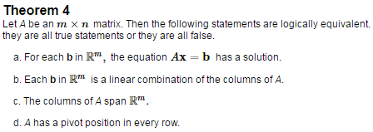



(Caveat/note: In Theorem 4, *A* is a coefficient matrix, not an augmented matrix.)

Compute  for  and .



Compute

1. 
2. 

(This is called the ______________ matrix, denoted by *I*)

If *In* represents *n*x*n* identity matrix, then  for every 

