**Vectors in **

A matrix with one column is called a _______________ ___________ or ___________

  

Vectors are ________________ if and only if the corresponding entries are equal.

The sum of the vectors and is the vector _________________.

The scalar multiple of vector  by a real number *c* is the vector  where each ___________ of is multiplied by *c.*

Given  and  find

1. 
2. 
3. 

Geometric Descriptions of 

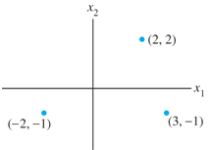 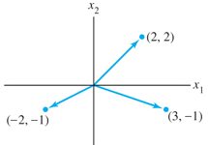

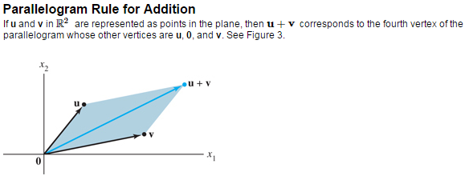

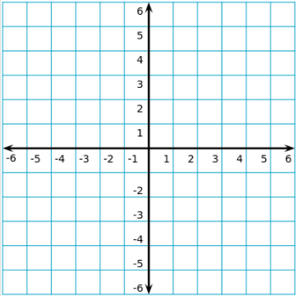 Given  and , draw their vectors and the following.

1. 
2. 

1. 

****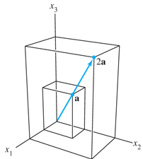**Vectors in **

**Vectors in **

The Zero vector has entries of all zero, denoted by or

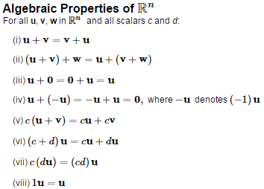

Prove (i)

Claim: 

Proof.

Let  be given.

Therefore .

Prove (v)

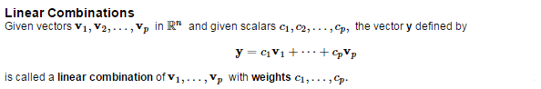

The figure identifies selected linear combinations of  and 

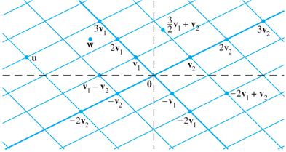

Determine whether  can be written as a linear combination of .

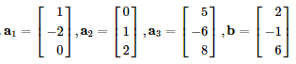

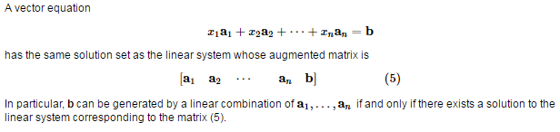

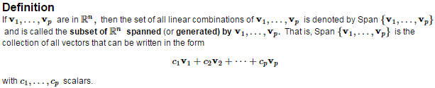

 means:

Every scalar multiple of individual vectors, 

Geometric Description of Span  and Span 

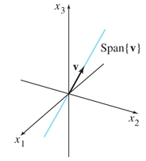 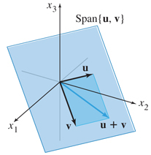

Let .  is a plane in .

Is **b** in that plane?



For what value(s) of *h* is **y** in the plane generated by **v**1 and **v**2?