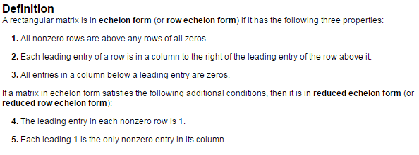

The following matrices that we saw in section 1.1 are in

 

_______________________ _______________________________

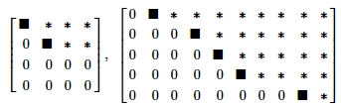Here are matrices in

Echelon Form

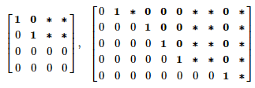

Reduced Echelon Form

Nonzero matrices can be row-reduced into many different matrices in Echelon form. However, the Reduced Echelon Form of any matrix is unique – there is only one.





Row reduce the matrix to echelon form, and locate the pivot columns.



Use elementary row operations to transform the following matrix into echelon form and then reduced echelon form.



Forward Phase vs. Backward Phase

**Solutions of Linear Systems**

**(revisited)** Looking at the reduced echelon form of the matrix from Ex 3, we can describe our solution set to the corresponding system of equations to this augmented matrix.

 🡪

The variables that are arbitrary, this text calls ________ variables, and the others that rely on those _______ variables or are fixed are called ____________ variables.

Find the general solution of the linear system whose augmented matrix has been reduced to



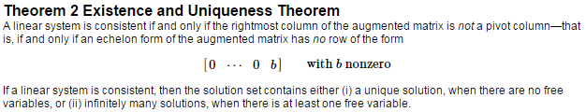

Determine the existence and uniqueness of the linear systems represented by the augmented matrices that we’ve seen over the last two sections.

1. (1.1, #4)



1. (1.1, #5)



1. (1.2, Ex 3 revisited)



