|  |  |
| --- | --- |
| Assessment 7Dusty Wilson Math 254 No work = no credit **No CAS Calculators** | **Name**: ________________________________ *I believe the true measure of a person is whether you have learnt to sacrifice yourself in the service of others.* Musa Manzi born in 1984 (South African Geoscientist) |

|  |  |  |
| --- | --- | --- |
| Warm-ups (1 pt each): | Centroid of the unit sphere (assuming uniform density) =____ | Expand  =_____ |

(1 pt) The quote by Manzi (above) is from the professor in the video this week. How does Manzi assess value in himself/others? Answer using complete English sentences.

(10 pts) Find the work done by the force field  on a particle the moves along the line segment from  to .

(10 pts) Find the gradient vector field  of  and sketch it. Note: Sketch vectors at all BIG dots. The vectors may extend off the grid.

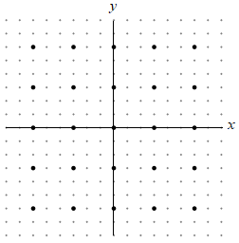

(10 pts) Use a change of variables to evaluate  where *R* is the region bounded by 

