|  |  |
| --- | --- |
| Assessment 2Dusty Wilson Math 254 No work = no credit **No CAS Calculators** | **Name**: ________________________________  *... arithmetic has a very great and elevating effect, compelling the soul to reason about abstract number, and rebelling against the introduction of visible or tangible objects into the argument.* Plato circa 428 – 348 BC (Greek Philosopher) |

|  |  |  |  |
| --- | --- | --- | --- |
| Warm-ups (1 pt each): | =_____ | =_____ | =_____ |

(1 pt) The quote by Plato (above) is from the same book as the Allegory of the Cave. According to Plato, what is it about numbers that distinguishes them from visible or tangible objects? Answer using complete English sentences.

(1 pt) Slack posting: What random number am I thinking of? _____

(10 pts) Carefully sketch a contour map of with four labeled contour lines.

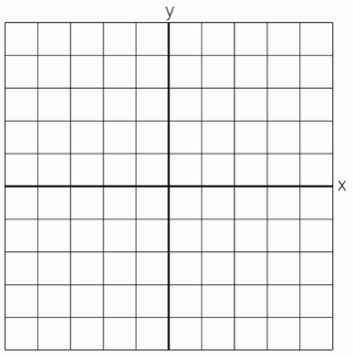

(10 pts) Find the equation of the tangent plane to the surface at the point .

(10 pts) If and  changes from  to , compare the values of  and . (Round your answers to four decimal places.)

(10 pts) If  where  and , use the multivariate chain rule to find . You may assume that all the given functions have continuous partial derivatives.