Test 3  Dusty Wilson  Math 220  No work = no credit  No Calculators | Name: ________________________________  Thus, the task is, not so much to see what no one has yet seen; but to think what nobody has yet thought, about that which everybody sees.  Erwin Rudolf Josef Alexander Schrödinger  1887 – 1961 (Austrian physicist)

Warm-ups (1 pt each): | =_____ | =_____ | =_____

(1 pt) According to Schrödinger, what is necessary to complete the task? (See above). Answer using complete English sentences.

(10 pt) Find the eigenvalues of and determine the stability of the zero state of the dynamical system .

(10 pts) Find the QR factorization of

Test 3  Dusty Wilson  Math 220  No work = no credit | Name: ________________________________  Thus, the task is, not so much to see what no one has yet seen; but to think what nobody has yet thought, about that which everybody sees.  Erwin Rudolf Josef Alexander Schrödinger  1887 – 1961 (Austrian physicist)

(10 pts) The matrix has eigenvalues 1 and 0.25.
If the distribution vector , find

(10 pts) Consider the rotation-scaling matrix . Find the angle of rotation (degrees or radians to two decimal places) and the scaling factor.

(15 pts) Consider

- Find both eigenvectors for given that .

- Find an invertible matrix S such that where a and b are real numbers.

(10 pts) What are the similarities and differences between an orthonormal basis and an eigenbasis for a subspace V?

- Similarities (at least 2)
- Differences (at least 2)

(9 pts) (True or False) Answer the following. 1 point per problem is for an explanation/justification:

- If is diagonalizable (over ), then there must be an eigenbasis for .

- There exists a real 5x5 matrix without any real eigenvalues.
- If is an eigenvalue of and is an eigenvalue of , then is an eigenvalue of AB.

(10 pts) Perform Gram-Schmidt orthogonalization on and and then illustrate your work with a sketch.

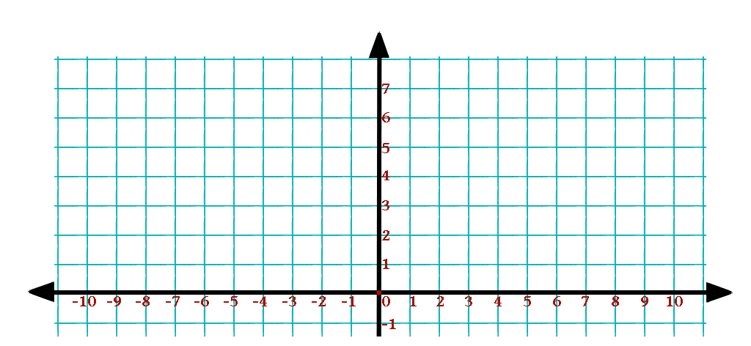

(10 pts) Prove that for every vector and a subspace V of we can write where is in V and is perpendicular to V.

In the warm-ups, refers to the standard basis vector in .

