Test 3  Dusty Wilson  Math 220  No work = no credit | Name: ________________________________  Mathematics is a game played according to certain  simple rules with meaningless marks on paper.  David Hilbert  1862 - 1943 (Prussian mathematician)

Warm-ups (1 pt each): Suppose
 | =_____ | =_____ | =_____

(1 pt) According to Hilbert, how much transcendent or intrinsic meaning is there in mathematics? (See above). Answer using complete English sentences.

(10 pts) Find the QR factorization of

(10 pts) Consider the experimental observations given in the following table:

Find the least-squares linear () fit to the data using techniques developed in linear algebra. Give exact (fraction) values in your answer.

Find the magnitude of the minimum error vector.
(5 pts) How do you determine if a matrix A is orthogonal?

(5 pts) Consider the sketch below.

- Clearly and carefully draw and label the orthogonal projection of onto the line L.

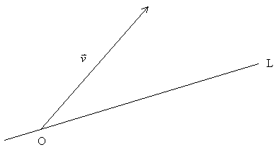
- Explain how you would find it given some vector and the equation of the line L: .

(5 pts) If is a factorization, prove equals .

(5 pts) Suppose you are given two vectors and in below and told to use Gram-Schmidt to generate an orthogonal basis spanning the plane. Clearly and carefully sketch and label these vectors given that .


(10 pts) Use the determinant to find out for which values of the constant the matrix fails to be invertible.

(6 pts) What are two geometric interpretations for ?

