Test 2  Dusty Wilson  Math 220  No work = no credit | Name: ________________________________  Nothing is more important than to see the sources of  invention which are, in my opinion more interesting  than the inventions themselves.  Gottfried Leibniz  1646 – 1716 (German mathematician)

Warm-ups (1 pt each): | =_____ | =_____ | =_____

(1 pt) What did Leibniz find most interesting about inventions? (See above). Answer using complete English sentences.

(10 pts) Use the given graph to answer the following:

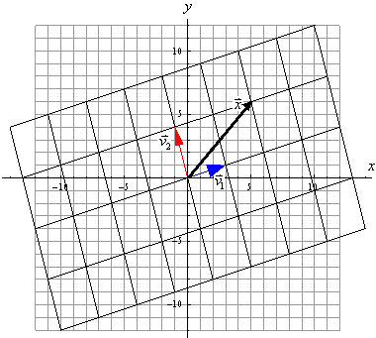
- and
- If and, find and graph

(10 pts) Consider the matrix

- Find the image of A.
- Find the kernel of A.
- rank(A) = _____ and nullity(A) = ____
(6 pts) Describe a basis, the conditions a basis must satisfy, and the meaning of those conditions.

(5 pts) Explain how you would go about proving an “if and only if” claim (sometimes denoted by “iff”) that:

Condition A is true if and only if Condition B is true.

(5 pts) Consider a linear transformation and linearly dependent vectors . Prove that are linearly dependent as well.

(10 pts) If , the basis , and , find and .

