Test 1 – Part A  Dusty Wilson  Math 220  No work = no credit  No Graphing Calculators | Name: ________________________________  You know that I write slowly. This is chiefly because I am never satisfied until I have said as much as possible in a few words, and writing briefly takes far more time than writing at length.  Johann Carl Friedrich Gauss  1777-1855 (German mathematician)

Warm-ups (1 pt each): | =_____ | =_____ | =_____
Note: The vectors above are in

(1 pts) According to Gauss (above), why did he write slowly? Answer using complete English sentences.

(6 pts) True or False (circle one).

- (True or False) If A is a 3 x 4 matrix and vector , the vector
- (True or False) If matrix A is in rref, then at least one of the entries in each column must be 1.
- (True or False)
(4 pts) What are four applications of matrices?

(4 pts) Use matrices to solve the system

(4 pts) The reduced row echelon form of an augmented system is given below. Write in vector form.

(4 pts) The vector is the solution to what matrix in rref?

(4 pts) Use Gauss-Jordan Elimination to solve the system with augmented matrix . Express your answer in vector form.

(4 pts) Write the augmented matrix for a system of linear equations that is inconsistent.

Test 1 – Part B  Dusty Wilson  Math 220  No work = no credit | Name: ________________________________  You know that I write slowly. This is chiefly because I am never satisfied until I have said as much as possible in a few words, and writing briefly takes far more time than writing at length.  Johann Carl Friedrich Gauss  1777-1855 (German mathematician)

(6 pts) True or False (circle one).

- (True or False) There exists a 3 x 4 matrix with rank 4.

- (True or False) If A is an n x n matrix and , then the product is a linear combination of the columns of matrix A.

- (True or False) If A and B are matrices of the same size, then the formula must hold.
(4 pts) If A is an n x m matrix and , prove .

(6 pts) Consider the circular face. Draw a sketch showing the effect of the linear transformation on this face. Make sure to clearly indicate the scale.
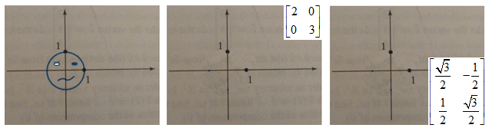
(6 pts) Parallelogram grid
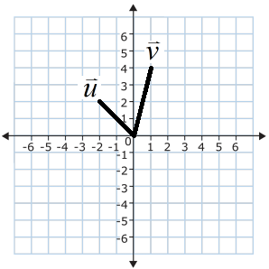
- Clearly graph and label the point on the grid.
- Find in terms of the vectors .
- If T is a linear transformation such that and , clearly graph and label the point .

