Test 1 – Part A  Dusty Wilson  Math 220  No work = no credit  No Graphing Calculators | Name: ________________________________  An elegantly executed proof is a poem in  all but the form in which it is written.  Morris Kline  1908-1992 (American mathematician)

Warm-ups (1 pt each): | =_____ | =_____ | =_____

(1 pts) According to Kline (above), how should a good proof be written? Answer using complete English sentences.

(8 pts) Consider . Find if it exists. If it doesn’t exist, write the letters of my first name in alphabetical order.

(10 pts) Consider the system of linear equations:

- Write the associated coefficient matrix A
- Solve the system using Gauss-Jordan Elimination. Express your solution as a vector. Fractions may be required …

- What is the rank of the coefficient matrix A found in (a.)?

Test 1 – Part B  Dusty Wilson  Math 220  No work = no credit | Name: ________________________________

(8 pts) Use linear algebra to find the polynomial of degree 2 (a polynomial of the form ) whose graph goes through the points , , and .

(8 pts) Answer the following:

(a.) Express as a linear combination of  and | (b.) Consider a linear transformation such that and . Sketch on the same axes.
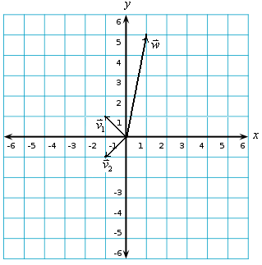

(6 pts) Answer the following. It may help to find an example to justify your answer.

- True or False: If matrices and are invertible, then the matrix is invertible.

- True or False: If then matrix A must be .

- True or False: There exists an invertible matrix with two identical rows.

(8 pts) Consider the circular face. For the matrix draw a sketch showing the effect of the linear transformation on this face.

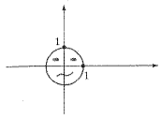

(8 pts) Find a rotation matrix A that transforms into .

(8 pts) Prove that if is a linear transformation, then for all

(8 pts) Write as the product of a matrix and a vector if and . What are the dimensions of A?

(8 pts) Suppose and L is the line .

- Find the projection of onto L.

- Find the component of perpendicular to the line L.

