Math 220
Review for Test 1

Tests: There will be tests which unless otherwise announced will have two parts:
- Part 1: No calculator portion of the exam
  - 50 minutes on Thursday
- Part 2: Calculator portion of the exam
  - 50 minutes on Friday

Material on the Exam
- The exam will begin with 3 warm-ups.
- You will need to interpret a quote using complete English sentences.
- The exam will cover the material in sections 1.1-3 and 2.1-2
- It is a closed book, closed note exam.
- In addition to the material covered in the class, you are responsible for all of the basic facts you have learned since kindergarten. These include the facts that Barack Obama was the President of the United States of America, , and that 1/0 is undefined.
- You must be able to answer warm up questions and paraphrase quotes such as the quote by the Scottish mathematician George Crystal who wrote, “Every mathematical book that is worth reading must be read ‘backwards and forwards,’ if I may use the expression. I would modify Lagrange's advice a little and say, ‘Go on, but often return to strengthen your faith.’ When you come to a hard or dreary passage, pass it over; and come back to it after you have seen its importance or found the need for it further on.”

Format
- The exam will last 50+50 minutes.
- It is a paper and pencil exam.
- You will need to show your work.
- The exam will include a “no calculator” portion that will focus on:
  - Gauss-Jordan elimination
  - Matrix arithmetic: addition, scalar multiplication, and multiplication by vectors
- You may use a graphing calculator for the calculator portion. However, you may not use a symbolic (CAS) calculator.
- The exam will include one proof.

In Studying . . .
- You should be able to solve every example done in class.
- You should be able to work all the proofs from class as well as their cousins (for example, if we proved part (a.) in class, you should be able to prove part (b.) on the exam).
- You should be able to solve every 10 point homework question.

Ideas that may help with test prep …
- Review the most recent material first.
- Summarize your notes. Make note cards for important formulas and definitions. Set them aside once the definitions are known.
- Rework examples from class and homework questions (in this order).
- Look to the T/F review exercises for additional practice. The solutions to these are posted on the website.
- Practice like you will play – do you know the material without your notes when the clock is running?
- Study with a friend to have more fun.
- Look to online resources such as YouTube and the Khan Academy to fill in holes.
- Show up at least five minutes early for the exam.
- Extra Credit: Recopying your notes and bring both copies with you (very clearly labeled) to the exam. You will be given credit for each section of notes recopied.

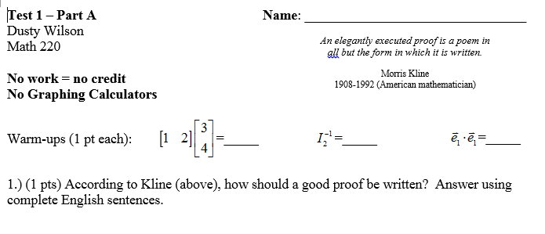
Figure 1: The format of your exam.

Notes on the sections (not necessarily exhaustive)

Chapter 1
- Matrix and vector vocabulary.
- Using Gauss-Jordan Elimination to solve systems of equations including interpreting the results. You must be able to do this by hand for a system of three equations and three unknowns (without a calculator).
  - Distinguish between RREF and REF.
- Understand the rank of a matrix and its impact. See examples 1-5 in section 1.3 as well as theorems 1.3.3 and 1.3.4.
- Perform basic matrix algebra including addition, scalar multiplication, and matrix multiplication. You should be able to prove properties of these operations.
- Linear combinations …
- You should be able to solve systems using a parallelogram grid.
- If a system has an infinite number of solutions, you should be able to write the solution in vector form using free variables.

Chapter 2
- Understand linear transformations, the definitions, properties, and the relation between the function T and the matrix A. You should be able to prove claims about linear transformations.
- You should be comfortable with the e_{i} notation for the standard basis vectors.
- You should be able to construct a transformation matrix by determining what the transformation does to the standard basis vectors.
- You should be able to work with linear transformations using a parallelogram grid.
- You should have a basic understanding of various geometric linear transformations including scaling, reflections, shear, rotations, and projections. You need to have the rotation matrix memorized. You may find it helpful to play with the bug CDF example on the website.

