|  |  |
| --- | --- |
| Group Quiz 2Dusty WilsonNo work = no credit | **Name**: ________________________________  ________________________________  ________________________________ |

Consider the parametrically curve:

 and 

1. Use your calculator and sketch a graph of the curve.
2. Find  (simplification is optional).
3. Set up an equation to find where the tangents are horizontal. Clearly show where these exist on the graph in (a.).
4. Set up an equation to find where the slope of the tangent does not exist. Clearly show where these exist on the graph in (a.). Find the exact coordinates of the point in the fourth quadrant.
5. Set up (do not solve) an integral to represent the arclength of the center section of the figure.

(No calculator) Carefully sketch a graph that includes  and . Make sure to label each graph. Find the point(s) of intersection and express the coordinate(s) in rectangular form.

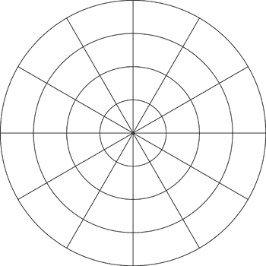

Find the area shared by the two cardioids in the previous question.