|  |  |
| --- | --- |
| Test 3aDusty Wilson Math 151 No work = no credit  No Symbolic Calculators | **Name:** ___________________________  *To divide a cube into two other cubes, a fourth power or in general any power whatever into two powers of the same denomination above the second is impossible, and I have assuredly found an admirable proof of this, but the margin is too narrow to contain it.*  Pierre de Fermat (1601 - 1665)  French mathematician |

|  |  |  |  |
| --- | --- | --- | --- |
| Warm-ups (1 pt each): | = | = | = |

(1 pt) According to Fermat (see above), how long do you think his admirable proof was?

(4 pts) Evaluate 

(4 pts) Suppose the derivative of  is . At what *x* value(s) does *f* have a minimum, maximum, and horizontal point of inflection?

Minimum: ______

Maximum: ______

Horizontal Point of Inflection: ______

(4 pts) A rock is thrown into a still pond. The circular ripples move outward from the point of impact of the rock so that the radius of the circle formed by a ripple increases at the rate of 3 feet per second. Find the rate at which the area is changing at the instant the radius is 6 feet.

(4 pts) Evaluate 

|  |  |
| --- | --- |
| Test 3Dusty Wilson Math 151 No work = no credit  No Sineful Calculators | **Name:** ___________________________  *To divide a cube into two other cubes, a fourth power or in general any power whatever into two powers of the same denomination above the second is impossible, and I have assuredly found an admirable proof of this, but the margin is too narrow to contain it.*  Pierre de Fermat (1601 - 1665)  French mathematician |

(4 pts) Find and clearly label all local and absolute extremes of  on 

(6 pts) Use the graph if *f* to complete the sign diagrams of *f* and its first and second derivative.

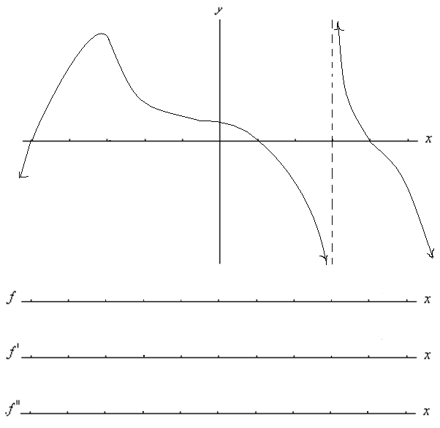

(5 pts) Use calculus to clearly and carefully sketch a graph of .



Find and label all *x*-intercepts, extrema (including *y*-values), and points of inflection (only *x*-values).

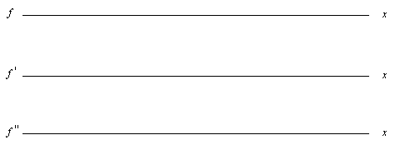

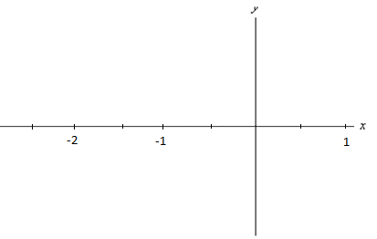

(4 pts) Use a linear approximation to estimate . Write your result as a decimal.