Multivariable Calculus
16.2: Line Integrals

Reading guide

- Look carefully at Figure 1 to solidify your understanding of the relationship between the parameter t and the curve C.
- Make sure that formulas and are in your notes.
- Play with formula … it is really handy. See if you can draw a graph between two points on your graphing calculator using this formula (in parametric mode). I like to think of this formula as giving you a vector that begins as “all r not” and ends with “all r one.”
- Work thru example 1 carefully.
- Review sections 6.4 and 12.3 to remind yourself of what we previously learned regarding “work.”
- Make sure that definition and its more helpful cousin in the box on page 1043 are in your notes (notice that this is another case where the definition isn’t terribly helpful in actually performing calculations, but it leads to a nice formula).
- Basic questions to test your comprehension
  - Place the three line integrals , , and in order from largest (most positive) to smallest (most negative).
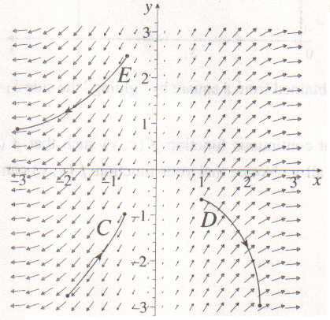
  - Evaluate where C is the line from to .

