|  |  |
| --- | --- |
| Test 1 (Version )Dusty Wilson Math 153 No work = no credit  No Symbolic Calculators | **Name:** ___________________________  *I myself, a professional mathematician, on re-reading my own work find it strains my mental powers to recall to mind from the figures the meanings of the demonstrations, meanings which I myself originally put into the figures and the text from my mind. But when I attempt to remedy the obscurity of the material by putting in extra words, I see myself falling into the opposite fault of becoming chatty in something mathematical.*  Johannes Kepler (1597 - 1630)  German astronomer |

|  |  |  |  |
| --- | --- | --- | --- |
| Warm-ups (1 pt each): | =_____ | =_____ | =_____ |

(1 pt) Based upon the quote above, how easily did Kepler understand his earlier work? Answer using complete English sentences.

(12 pts) Consider  and .

1. Find 

1. Find 
2. Find 

(10 pts) Use the graphs of  and  to carefully sketch the parametric curve . Indicate with arrows the direction which the curve is traced as *t* increases.

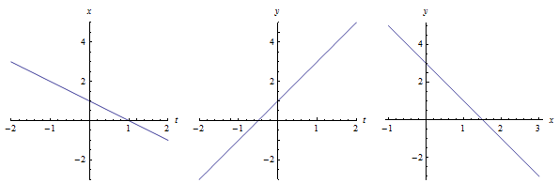

(12 pts) Draw the projections of the curve  on the three coordinate planes.

|  |  |  |
| --- | --- | --- |
| *xy* plane | *xz* plane | *yz* plane |

(12 pts) Consider the plane 

1. Find the distance from the plane to the point .
2. Find the equation of the line that is normal to the plane through point *A*. Give your answer parametrically.

(10 pts) Find an equation of the plane that passes through the point (−1, 1, 2) and contains the line of intersection of the planes *x* + *y* − *z* = 2 and 2*x* − *y* + 3*z* = 4

(10 pts) Consider the equation. Reduce the equation to one of the standard forms. Classify the surface and give its center.

(10 pts) Determine Angle A (you may give your answer in either degrees or radians).

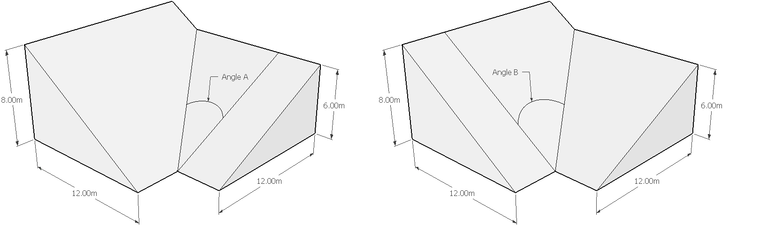

|  |  |
| --- | --- |
| Test 1 (Version *e*)Dusty Wilson Math 153 No work = no credit  No Symbolic Calculators | **Name:** ___________________________  *I myself, a professional mathematician, on re-reading my own work find it strains my mental powers to recall to mind from the figures the meanings of the demonstrations, meanings which I myself originally put into the figures and the text from my mind. But when I attempt to remedy the obscurity of the material by putting in extra words, I see myself falling into the opposite fault of becoming chatty in something mathematical.*  Johannes Kepler (1597 - 1630)  German astronomer |

|  |  |  |  |
| --- | --- | --- | --- |
| Warm-ups (1 pt each): | =_____ | =_____ | =_____ |

(1 pt) Based upon the quote above, how easily did Kepler understand his earlier work? Answer using complete English sentences.

(12 pts) Consider  and .

1. Find 
2. Find 

1. Find 

(10 pts) Use the graphs of  and  to carefully sketch the parametric curve . Indicate with arrows the direction which the curve is traced as *t* increases.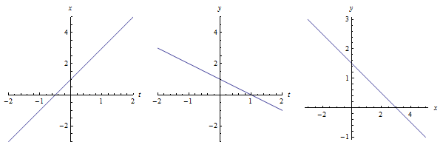

(12 pts) Consider the plane 

1. Find the distance from the plane to the point .
2. Find the equation of the line that is normal to the plane through point *A*. Give your answer parametrically.

(12 pts) Draw the projections of the curve  on the three coordinate planes.

|  |  |  |
| --- | --- | --- |
| *xy* plane | *xz* plane | *yz* plane |

(10 pts) Find an equation of the plane that passes through the point (−1, 2, 2) and contains the line of intersection of the planes *x* + *y* − *z* = 3 and 2*x* − *y* + 3*z* = 4

(15 pts) Consider the equation. Reduce the equation to one of the standard forms. Classify the surface and give its center.

(15 pts) Determine Angle B (you may give your answer in either degrees or radians).

