|  |  |
| --- | --- |
| Group Quiz 1Dusty Wilson Math 153 – Spring 2012 No work = no credit | **Name**: ________________________________  ________________________________  ________________________________ |

Consider the parametrically curve:

 and 

1. Use your calculator and sketch a graph of the curve.
2. Find  (simplification is optional).
3. Set up an equation to find where the tangents are horizontal. Clearly show where these exist on the graph in (a.).
4. Set up an equation to find where the tangent does not exist. Clearly show where these exist on the graph in (b.).
5. Set up (do not solve) an integral to represent the arclength of the figure.

(No calculator) Carefully sketch a graph that includes  and . Make sure to label each graph. Find the point(s) of intersection and express the coordinate(s) in polar form.

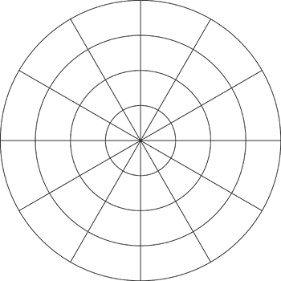

Find the area of the outer region when *x* > 0 bounded between the two curves in the previous question. For glory and fame, find the inner area as well.