Test 1 – Part A  Dusty Wilson  Math 220  No work = no credit  No Graphing Calculators | Name: ________________________________  You know that I write slowly. This is chiefly because I am never satisfied until I have said as much as possible in a few words, and writing briefly takes far more time than writing at length.  Johann Carl Friedrich Gauss  1777-1855 (German mathematician)

Warm-ups (1 pt each): | =_____ | =_____ | =_____

(1 pts) According to Gauss (above), why did he write slowly? Answer using complete English sentences.

(8 pts) Consider . Find (if it exists) using row reduction. If it doesn’t exist, write the letters of my first name in alphabetical order.

(4 pts) If and , find

(8 pts) Solve the system of linear equations using Gauss-Jordan Elimination

(4 pts) Evaluate

Test 1 – Part B  Dusty Wilson  Math 220  No work = no credit | Name: ________________________________

(9 pts) Suppose and is as given below. Give in vector form.

a.) | b.) | c.)

(8 pts) Consider the circular face. Draw a sketch showing the effect of the linear transformation on this face. Make sure to clearly indicate the scale.
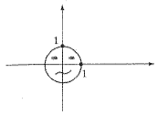

(8 pts) Answer the following:  (a.) Express as a linear combination of  and | (b.) Consider a linear transformation such that and . Sketch
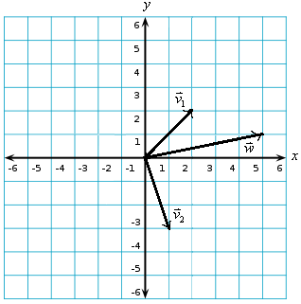

(8 pts) Write as a linear combination of the columns of A.

(6 pts) Answer the following. It may help to find an example to justify your answer.

- True or False: The entries must be 0 or 1 in a matrix in reduced row echelon form (rref).

- True or False: If , and are nonzero vectors in , then must be a linear combination of and .

- True or False: If then the matrix A must be .

(8 pts) Find a rotation matrix A that transforms into . Give exact values.

(8 pts) Prove that if A is an n x m matrix, k is a scalar, and , then

(8 pts) Suppose and L is the line .

- Find the projection of onto L. Give exact values.

- Find the component of perpendicular to the line L. Give exact values.

