Test 1 – Part A  Dusty Wilson  Math 220  No work = no credit  No Graphing Calculators | Name: ________________________________  An elegantly executed proof is a poem in  all but the form in which it is written.  Morris Kline  1908-1992 (American mathematician)

Warm-ups (1 pt each): | =_____ | =_____ | =_____

(1 pts) According to Kline (above), how should a good proof be written? Answer using complete English sentences.

(8 pts) Consider

Find if it exists. If it doesn’t exist, write the letters of my first name in alphabetical order.

(10 pts) Consider the system of linear equations:

- Write the associated coefficient matrix A
- Solve the system using Gauss-Jordan Elimination. Express your solution as a vector. Fractions may be required …

- What is the rank of the coefficient matrix A found in (a.)?

Test 1 – Part B  Dusty Wilson  Math 220  No work = no credit | Name: ________________________________
(4 pts) Suppose A is an invertible matrix. Explain two methods for solving .

(8 pts) Answer the following:

(a.) Express as a linear combination of  and | (b.) Consider a linear transformation such that and . Sketch on the same axes.
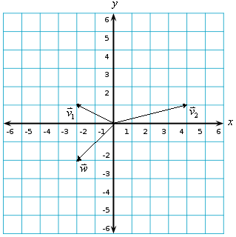

(4 pts) Consider a transformation that first performs a horizontal stretch by a factor of 2 and then a counter clockwise rotation by . Is this equivalent to the transformation that does the rotation first followed by the stretch? Explain your answer.

(Hint: remember the bug).

(4 pts) A linear transformation can be written as . What are the dimensions of the matrix A?

(4 pts) Consider the equation .

- Is it possible for the equation to have “no solution?” Why or why not?
- What is the greatest number of free variables possible? What is the least?

(5 pts) Prove that the inverse of a matrix A is unique.

(8 pts) Regarding linear combinations.

a.) What is a linear combination? Explain using arbitrary examples (don’t assume specific dimensions).
b.) What is the relationship between linear combinations and matrices?

(8 pts) Suppose and L is the line .

- Find the projection of onto L.
- Find the component of perpendicular to the line L.

