Test 1  Dusty Wilson  Math 220  No work = no credit  No Graphing Calculators | Name: ________________________________  An elegantly executed proof is a poem in  all but the form in which it is written.  Morris Kline  1908-1992 (American mathematician)

Warm-ups (1 pt each): | =_____ | =_____ | =_____

(1 pts) According to Kline (above), how should a good proof be written? Answer using complete English sentences.

(8 pts) Consider

- Find if it exists. If it doesn’t exist, write my middle name backwards.

- If , solve

(7 pts) Consider the system of linear equations:

- Write the associated coefficient matrix A
- Solve the system using Gauss-Jordan Elimination. (Fractions may be required …)

- What is the rank of the coefficient matrix A found in (a.)?

(8 pts) Answer the following:

(a.) Express as a linear combination of  and | (b.) Consider a linear transformation such that and . Sketch on the same axes.
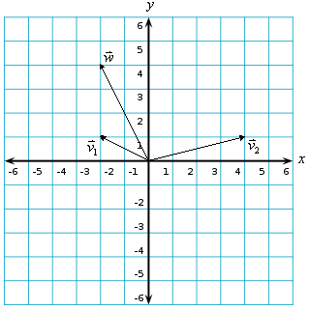

(4 pts) Give an example a geometric linear transformation that has the following property. Your answer should be the name of a transformation, not a specific matrix. (Hint: remember the bug).
- An invertible geometric linear transformation
- A non-invertible geometric linear transformation

(4 pts) A linear transformation can be written as . What are the dimensions of the matrix A?

(4 pts) Suppose the equation is solved given that .

- Is it possible for the equation to have “no solution?” Why or why not?
- How many free variables are there?

(4 pts) Prove that if is a linear transformation, , and k is a scalar, then .

(4 pts) Consider where .

- Write the sum as the product of a matrix and a vector. Clearly indicate the contents of the matrix and vector in terms of the x’s and v’s.

- What are the dimensions of the matrix? What are the dimensions of the vector?

(4 pts) Find the scaling matrix A that transforms into

(4 pts) Find the rotation matrix B that transforms into

