Test 1  Dusty Wilson  Math 220  No work = no credit | Name: ________________________________  The object of pure physics is the unfolding of the laws of  the intelligible world; the object of pure mathematics  that of unfolding the laws of human intelligence.  James Joseph Sylvester  1814 – 1897 (English mathematician)

Warm-ups (1 pt each): | =_____ | =_____ | =_____

(1 pts) According to Sylvester (above), what is the difference between pure math and physics? Answer using complete English sentences.

(20 pts) Consider the equation .

- What are two approaches you could use to solve this equation?
  - Method 1:
  - Method 2:
- With respect to your methods, will these work all of the time or are there conditions A must satisfy for the methods to be successful?
  - Method 1:
  - Method 2:
(10 pts) Let and .
- Solve the equation for x.
- Set up the augmented matrix you would use to find .

(10 pts) Write an augmented matrix in reduced row echelon form whose general solution in vector form is:

(5 pts) When we solve equations by factoring, we make use of the zero product rule which states that iff or . This is true for scalars a and b, but is not true for matrices. Give an example of two non-zero matrices whose product is the zero matrix.

(10 pts) Show that the vectors , , and are linearly dependent.

(9 pts) Prove that if A is an matrix and C is an matrix, then .

(10 pts) Determine the currents thru the three resistors.
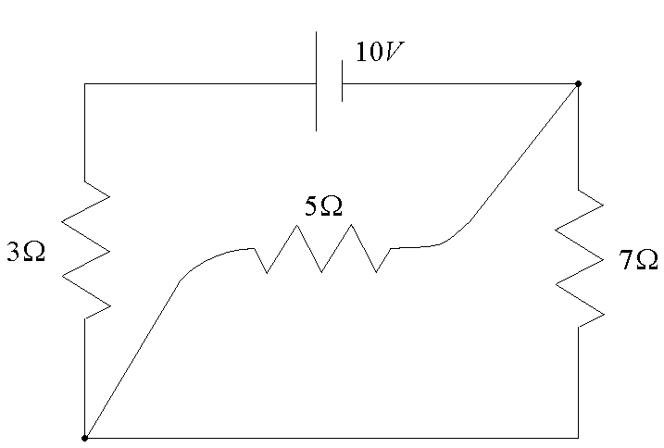

(10 pts) Find A if A is and . If you use a calculator, make sure you explain your process.

