Test 1 – Part A  Dusty Wilson  Math 220  No work = no credit  No Graphing Calculators | Name: ________________________________  An elegantly executed proof is a poem in  all but the form in which it is written.  Morris Kline  1908-1992 (American mathematician)

Warm-ups (1 pt each): | =_____ | =_____ | =_____

(1 pts) According to Kline (above), how should a good proof be written? Answer using complete English sentences.

(8 pts) Consider . Find if it exists. If it doesn’t exist, write the letters of my first name in alphabetical order.

(8 pts) Consider the system of linear equations:

Solve the system using Gauss-Jordan Elimination. Express your solution as a vector. Fractions may be required …

Test 1 – Part B  Dusty Wilson  Math 220  No work = no credit | Name: ________________________________

(4 pts) If the rank of a 5x3 matrix A is 3, what is rref(A)?

(4 pts) Write as a product.

(8 pts) Answer the following:  (a.) Express as a linear combination of  and | (b.) Consider a linear transformation such that and . Sketch
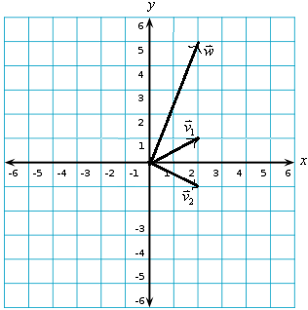

(6 pts) Answer the following. It may help to find an example to justify your answer.

- True or False: If matrices A and B commute, then the formula must hold.

- True or False: There exists a 2x3 matrix A and a 3x2 matrix B such that

- True or False: There exists an invertible 10x10 matrix that has 92 ones among its entries.

(8 pts) Consider the circular face. For the matrix draw a sketch showing the effect of the linear transformation on this face.

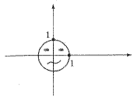

(8 pts) Find a rotation matrix A that transforms into . Give exact values.

(8 pts) Prove that if A is an n x m matrix and , then

(8 pts) Write the product as a linear combination. Be sure to carefully define A and .

(8 pts) Suppose and L is the line .

- Find the projection of onto L.

- Find the component of perpendicular to the line L.

