Test 3  Dusty Wilson  Math 148  No work = no credit | Name: ___________________________  Television is something the Russians invented  to destroy American education.  Paul Erdös (1913 - 1996)  Hungarian mathematician

Warm-ups (1 pt each): | =_____ | =_____ | =_____

(1 pt) According to Erdös, what was the purpose motivating the invention of the television?

(4 pts) | (4 pts)
__________________________ | __________________________

(4 pts) If consumption is $8 billion when income is 0, and if the marginal propensity to consume is (in billions of dollars), find the national consumption function.

__________________________
(4 pts)

__________________________

(4 pts)

__________________________

(4 pts)

__________________________
(8 pts) The marginal cost of producing a product is , where x represents the number of units produced per week. If the marginal revenue from the sale of x units is $174 and if the fixed costs of production are $4,300, answer the following.

i.) (1 pt) How many units should the firm produce and sell each week to maximize its profit?

___________________

ii.) (1 pt) Find the profit function.

___________________

iii.) (2 pts) Find and interpret the value of the profit function when evaluated at the optimal level of production (found in (a.)).

(4 pts) What does the definite integral represent?

(4 pts) Verify the formula:.

(4 pts) Estimate the area under on with Simpson’s rule using four subdivisions of equal width. Show enough work to convince me you knew what you were doing. Give your answer to 5 decimal places.

(4 pts) Neatly sketch a graph showing how you would use 4 subintervals of equal with and right endpoints to approximate the area under on the interval . No calculations are required.

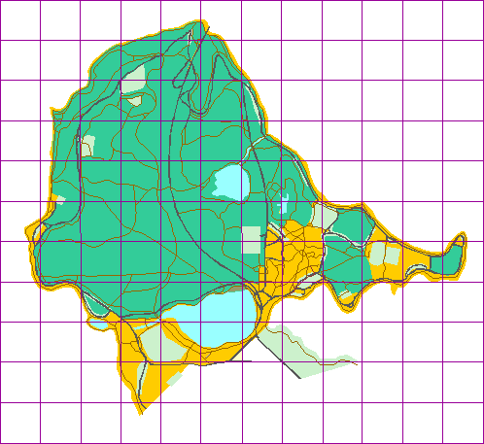
(4 pts) The given map shows Stanley Park. If each square represents 100 square yards, approximate the area of the park to within 300 square yards.

___________________

