Test 3  Dusty Wilson  Math 148  No work = no credit | Name: ___________________________  Television is something the Russians invented  to destroy American education.  Paul Erdös (1913 - 1996)  Hungarian mathematician

Warm-ups (1 pt each): | =_____ | =_____ | =_____

(1 pt) According to Erdös, what was the purpose motivating the invention of the television?

(4 pts) | (4 pts)
__________________________ | __________________________

(4 pts)

__________________________
(4 pts)

__________________________

(4 pts)

__________________________

(4 pts)

__________________________
(8 pts) A firm knows that the marginal costs of producing x units is , there is marginal revenue of , and that the cost to produce 2 units is $146. Find the optimal profit (or loss) for the firm and give your recommendation for how they should proceed.

(4 pts) Approximate the area under the line on using n rectangles of equal width with right hand end points. (It is not necessary to use notation).

(4 pts) Express the area under on the interval as a definite integral (picture below).

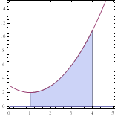

___________________

(4 pts) Verify the formula: .

___________________
(4 pts) Find the value of the sum using summation formulas.

___________________

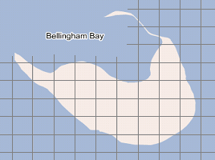
(4 pts) The given map shows a small island in Bellingham Bay (Bellingham is a few miles to the east of the island). If each square represents 100 square yards, approximate the area of the island to within 300 square yards.

___________________

