|  |  |
| --- | --- |
| Test 2Dusty Wilson Math 148 No work = no credit | **Name**: _____________________________________________  *Seeing there is nothing that is so troublesome to mathematical practice, nor that doth more molest and hinder calculators, than the multiplications, divisions, square and cubical extractions of great numbers ... I began therefore to consider in my mind by what certain and ready art I might remove those hindrances.*  John Napier (1550 - 1617)  Scottish mathematician |

|  |  |  |  |
| --- | --- | --- | --- |
| Warm-ups (1 pt each): | =_____ | =_____ | =_____ |

(1 pt) The quote by John Napier (above) gives his reasoning behind the invention of the logarithm. In your own words, why did Napier invent the logarithm?

Formulas upon request (note that the pound symbol “#” refers to the word “number”):



(4 pts) Find the *x* and *y* intercept(s) and vertical and horizontal asymptote(s): 

*x*-intercepts: _______ *y*-intercepts: _______hor. asym*.*: _______ ver. asym: _______

(4 pts) Find the derivative of  (simplification is optional)

____________________________________________________

(6 pts) Use the graph if *f* to complete the sign diagrams of *f* and its first and second derivative.

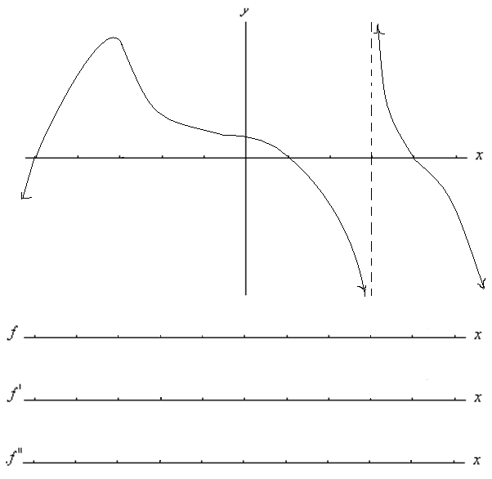

(4 pts) Find the derivative of  (simplification is optional)

____________________________________________________

(10 pts) Use calculus to clearly and carefully sketch a graph of .



Find and label all *x*-intercepts, extrema, and points of inflection. Find the absolute minimum of *f* on the interval . You may check with your calculator, but all work must be shown.

1. (8 points) Curve sketching (show work)

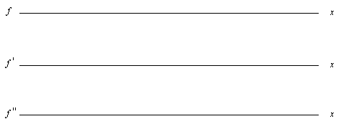

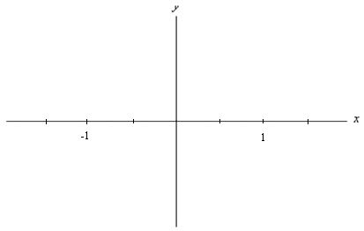

1. (2 points) Use calculus to find the absolute maximum of *f* on the interval  (show work)

(8 pts)Complete two of the following three questions. Cross out the problem you do not want graded. I retain the right to grade any two problems if you do not select for yourself.

a.) Suppose that a company needs 60,000 items during a year and that preparation for each production run costs $400. Suppose further that it costs $4 to produce each item and $0.75 to store an item for one year. Use the inventory cost model (see page 1) to find the number of items in each production run that will minimize the total costs of production and storage.

b.) Find and interpret the elasticity of the demand function  at . How will a price increase affect total revenue?

c.) If the demand function for a fixed period of times is given by

D:  and the supply function before taxation is S: , find the tax that would maximize the total tax revenue from this market.