Test 1  Dusty Wilson  Math 148  No work = no credit | Name: ________________________________  It is rare to find learned men who are clean, do  not stink and have a sense of humour.  Duchess of Orléans

Warm-ups (1 pt each): | =_____ | =_____ | =_____
(1 pt) The quote above is attributed to the Duchess of Orléans regarding Gottfried Leibniz (the co-discover/inventor of calculus). What special qualities did Leibniz have? Use complete English sentences.

(16 pts) Find the derivatives of the following: (Simplification is optional).

- (4 pts)

__________________________________________________________

b.) (4 pts)

__________________________________________________________

c.) (4 pts)

__________________________________________________________

d.) (4 pts)

__________________________________________________________
(4 pts) Find f ′′(x) if .

_________________________________________

(4 pts) If , find

__________________________________________________________

(5 pts) Given the function f (x) shown in the graph to the right, evaluate the following:

a.) = _______  b.) = _______  c.) = _______  d.) = ________ | 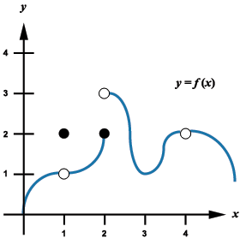

e.) Is continuous at ? Explain why or why not using the definition of continuity?

(4 pts) Consider

- = ______________
- = ______________

- = ______________

- = _______________

(4 pts) Consider the function .
- Find

- Find the equation of the tangent line when
- Find the y value on the tangent line from (b.) corresponding to .
- Compare the results of (a.) and (c.) and explain the similarity of the results.

(4 pts) Consider the function: (Show work for (b.)).

a.) = _____________ | b.) = _____________
(4 pts) Use the definition of the derivative to find if

_________________________________________

(8 pts) Below are the total cost and revenue functions for producing and selling x units.

- Write the total profit function . | - Graph the on the window  [-20, 100, -5000, 8000] and draw what you see in the box below.

- Find and interpret .

- Find and interpret .
- Find and interpret .

