|  |  |
| --- | --- |
| Group Quiz 3Dusty Wilson Math 148 – Fall 2011 No work = no credit **No calculators** | **Name**: ________________________________  ________________________________  ________________________________ |

Use calculus (sign diagrams etc.) to carefully sketch . Include all relative maxima, relative minima, and points of inflection.

Use the given sign diagrams of *f*, its derivative, and second derivative to sketch a graph of *f* that captures all of its important features (intercepts, max/mins, points of inflection, cusps, …).

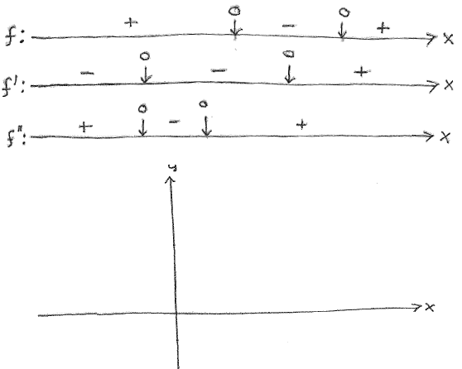

Consider the graph of  given below and use the graph to complete the sign diagrams for *g*, its derivative, and second derivative. Use the same scale on the sign diagrams as is given in the graph itself.

