Group Quiz 4  Dusty Wilson  Math 115  Calculators Allowed | ______________________________________  ______________________________________  ______________________________________  If others would but reflect on mathematical truths as deeply and continuously as I have, they would make my discoveries.  Carl Friedrich Gauss (1777 – 1855)  German mathematician

1.) Sketch a graph of the rational function .0... Be sure your graph includes all intercepts, asymptotes, and the appropriate end behavior.

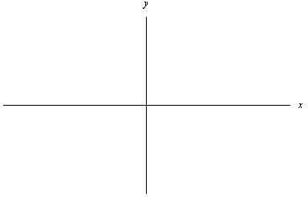

2.) Factor completely given that .

3.) Sketch a rational function with a horizontal asymptote at and the given sign diagram.
