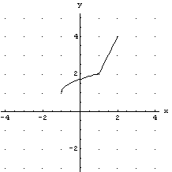
Transformations of a g(x)

The complete graph of $g(x)$is given to the right:

Match the graphs with the algebraic representations of the transformations.

Write the letter of the appropriate graph in the box containing the appropriate algebraic expression. If no graph matches a given expression, write “NONE.”

1. $\frac{1}{2}g(x)$ H | 4. $g(|x|)$ | 7. $2g(x)$ | 10. $g^{−1}(x)$ | 13. $g(2x)$
2. $g(−x)$ | 5. $g[g^{−1}(x)]$ | 8. $|g(x)|$ | 11. $g(x)+1$ | 14. $g(2x+2)$
3. $g(x−2)$ | 6. $g(\frac{1}{2}x)$ | 9. $g(x)−3$ | 12. $g(x+1)$ | 15. $g^{−1}[g(x)]$

A. | 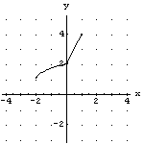 | B. | 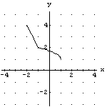 | C. | 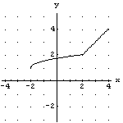
D. | 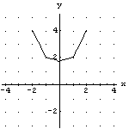 | E. | 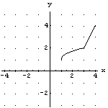 | F. | 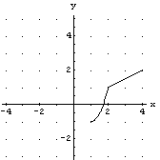
G. | 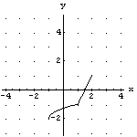 | H. | 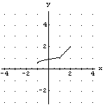 | I. | 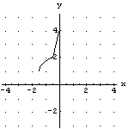
L. | 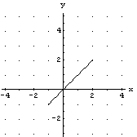 | M. | 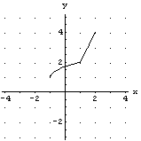 | N. | 