Handout – Logarithmic Regression
Dusty Wilson
Math 115

Why were Logarithms invented?

The Inventor: John Napier  Seeing there is nothing that is so troublesome to mathematical practice, nor that doth more molest and hinder calculators, than the multiplications, divisions, square and cubical extractions of great numbers ...  I began therefore to consider in my mind by what certain and ready art I might remove those hindrances.  Born: 1550 in Merchiston Castle, Edinburgh, Scotland  Died: 4 April 1617 in Edinburgh, Scotland | 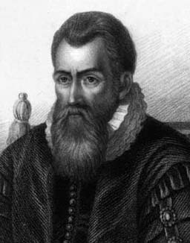

However, the calculator has antiquated the original usage of the logarithm.

What are Logarithms used for today?

One application of logs that is currently in practice is using the logarithm for curve fitting. This is perhaps more properly labeled logarithmic regression. What follows is an example where we attempt to find a model for the U.S. population density from 1790 to 1970.

Plot this data on your calculator.
Year | Population per mi²
1790 | 4.5
1810 | 4.3
1830 | 7.4
1850 | 7.9
1870 | 10.9
1890 | 17.8
1910 | 26.0
1930 | 34.7
1950 | 42.6
1970 | 57.5

This will require entering the data in L1, L2, and then performing a ZOOMSTAT using the appropriate STATPLOT.

Fit a linear model to this data.

The command is: LinReg(ax + b) L1, L2, Y1

Is this a good model? Why or why not? (Consider the residuals).
We will plot using semi-log paper. The coordinates on the paper are of the form.

The horizontal axis gives the year beginning at 1790 and ending at 1830. The vertical axis gives the population density on a log scale . Make sure you label your graph paper.

Plot the data from page one.

Sketch a best-fit line to the data on the semi-log paper.
Find two points on the curve.

Point A:

Point B:

What is the slope of the line?

What is the equation of the line ? Remember that , so, the equation of the line can also be written .

Solve for y.

Enter your new exponential model into your calculator and see how well it fits the data.

How close is your model to that found using log regression on the calculator?

