Handout – Composition, part 1
Dusty Wilson
Math 115

Example 1
Let f(x) = __________________ and g(x) = __________________.

a.) Find the domain of f.

Domain of f: D_{f} = { x | ___________________}

b.) Find the domain of g.

Domain of g: D_{g} = ______________________.

c.) Create a table of values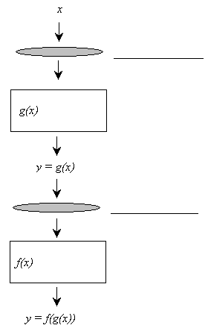.
x | -6 | -5 | -4 | 3 | 4 | 5
g(x)
f(g(x))

d.) Find

____________________________

e.) If we call the expression found in (d.) the
apparent composition (AC), find D_{AC}.

Domain of AC: D_{AC} = ______________________.

f.) The domain of is _____________________________________________________.

g.) Domain of : = __________________________________________________.

Example 2
Let and . Find and and the domains of each composition.

a.) Find the domain of f and g.

D_{f} = _________________________ D_{g} = _________________________

b.) Find .

= ______________________________

c.) What is the domain of the apparent composition?

D_{AC} = _____________________________.

d.) What is ?

= ____________________________________________________.

e.) Find .

= ______________________________

f.) What is the domain of the apparent composition?

D_{AC} = _____________________________.

g.) What is ?

= ____________________________________________________.

Handout – Composition, part 2
Dusty Wilson
Math 115

Example 3 (2.5 #81)
Let and . Find and and the domains of each composition.

a.) Find the domain of f and g.

D_{f} = _________________________ D_{g} = _________________________

b.) Find .

= ______________________________
c.) What is the domain of the apparent composition?

D_{AC} = _____________________________.

d.) What is ?

= ____________________________________________________.
e.) Find .

= ______________________________
f.) What is the domain of the apparent composition?

D_{AC} = _____________________________.
g.) What is ?

= ____________________________________________________.
Example 4 (2.5 #84)
Let and . Find and and the domains of each composition.

a.) Find the domain of f and g.

D_{f} = _________________________ D_{g} = _________________________

b.) Find .

= ______________________________

c.) What is the domain of the apparent composition?

D_{AC} = _____________________________.

d.) What is ?

= ____________________________________________________.

e.) Find .

= ______________________________

f.) What is the domain of the apparent composition?

D_{AC} = _____________________________.

g.) What is ?

= ____________________________________________________.

