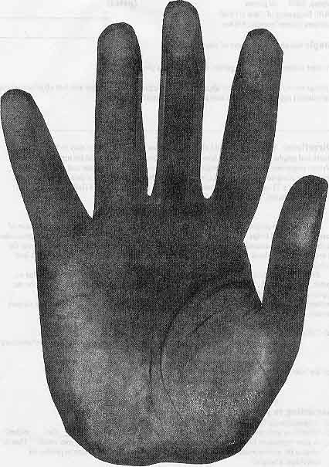
The Hand of a Thief
Math 115
Dusty Wilson

Due in Three Parts

The Scenario
Dalibor’s science project was at work. The light sensitive paper was left to capture pictures of various leaves and twigs. Hours later, Dalibor returned to check on his experiment. As he proceeded to rinse the paper, instead of seeing prints of the assorted leaves, a handprint (see the next page for the actual print) stared back at him, covering the work on which the precious (and fading) sunlight had toiled.

Mike, the local sheriff, was contacted to see if the fingerprints could be traced, but alas a match was not found. To narrow down the list of suspects, Mike advised Dalibor to determine the approximate height of the perpetrator. Dalibor is depending on you to use your advanced mathematics expertise to establish the approximate height of the culprit who ruined the science project.

Part 1 – 25 points
Collect the Data
Due at the start of class on January 12, 2004

- Read the example entitled “Data Analysis” that is on the Math 115 web site. To get to the example, go to http://flightline.highline.edu/dwilson. Click on the link to “Math 115” and then click on the “Data Analysis” link. Work through the example carefully. Follow along on your calculator and do not proceed until you understand each step.
- Decide on the data that you wish to collect. Be sure to specify what measurements you are using i.e. physically, what/where are you measuring.
- Collect the data. Include units with all of your measurements. Remember that your goal is to determine the height of the perpetrator. So beware of extrapolation, that is, using your model to predict values outside the region of observations.
- Submit a typed document that includes the results from (b.) and (c.).

Part 2 – 25 points
Data Analysis
Due at the start of class on January 20, 2004

- Find a linear model for your data using the linear regression command on your calculator.
- Calculate the residuals.
- Determine the sample standard deviation of your residuals.
- Determine the error bounds of your model.
- Submit a computer-generated graph that includes your data, your linear model, and your error bounds.
Part 3 – 50 points
Final Report
Due at the start of class on February 02, 2004

Your final report must be at least 2 typed pages, a cover page, and well-labeled graphs. You should have 1.25-inch margins and use 12-point Times New Roman font with double spacing. Include a cover page that includes your name(s), the title of your report, and any other pertinent information.

Your Final Report should include and answer the following questions:
- An outline of the scenario.
- A clearly labeled table of data, a scatter plot with regression line, a residual plot, and a plot with the data, regression line, and error bounds (as in Part 2e). All graphs must be computer-generated.
- Analysis of your model that includes (but is not limited to):
  - An interpretation of the slope of your model.
  - An interpretation of both intercepts of your model.
  - Is your regression line a reasonable model for your data? How good is your model? That is, what is the approximate error using the measurement you chose to predict an individual’s height?
  - What does your model indicate about your instructor’s hand, if he is 6 feet 1 ½ inches tall?
- Conclusion for Dalibor and Mike.
  - Approximately how tall is the culprit?
  - What are the error bounds on this approximation?
  - What conclusions and/or suggestions do you have for Mike and Dalibor?

Additional Notes
This is a group project and up to three students may work together on the project.

Your results should clearly show your reasoning and be easy to follow. All charts and graphs must be labeled and in correct units. All variables must be defined. Written responses should be in complete sentences, with proper grammar and spelling. Word processing is expected. Originality, creativity, and clarity may be rewarded

Graph links, which are capable of printing your data, scatter plots, etc. directly from a TI calculator into your document are available in the Math Lab. I will notify you of times when you may use this lab.

Please feel free to ask me questions regarding the project. I am here to help.

Enjoy yourself.
Here is the handprint of the perpetrator

