An arc on the unit circle of length t ends at the point whose x-coordinate is c. Knowing that , find the following in terms of c. Hint: Determine the quadrant where t located and plot a possible location for the point.
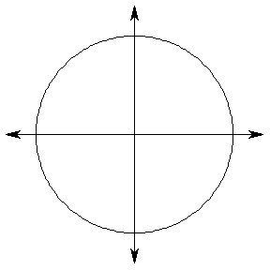
a.) |  | __________
b.) |  | __________
c.)
d.) |  | __________
e.) |  | __________
f.) |  | __________
g.) |  | __________
h.) |  | __________

An arc on the unit circle of length t ends at the point whose x-coordinate is c. Knowing that , find the following in terms of c. Hint: Determine the quadrant where t located and plot a possible location for the point.
a.) |  | __________
b.) |  | __________
c.)
d.) |  | __________
e.) |  | __________
f.) |  | __________
g.) |  | __________
h.) |  | __________

